AutoCAD 2D, AutoCAD 3D, Autodesk Inventor Style Sheet
Last revised: July 21, 2021
House Style: BCcampus Open Education Publishing Style Guide
Author(s): Wally Baumback
Editor(s): Jennifer Adachi

Competency Tests
- In this Pressbook, the modules are grouped into parts based on these competency tests. At the end of each competency test, a new part begins.
- I think we might try to put the info about each competency test at the beginning of the book and link to it rather than repeat it with every competency test. May change mind later, so skip it for now.
- Use the ordered list option in Pressbooks. To get the sub lists to display as letters rather than numbers, go into the HTML and add the following to the <ol> tag: type="A" so it would look like <ol type="A">

Headings
- Headings in each chapter always start with heading 1
- Sub headings are heading 2, then heading 3, etc
- Workalongs always start at heading one (see the section on workalongs)

Images

How to insert and resize images
- Download the images from the source document (click on then in Word and select "Save as Picture")
  - If the image cannot be saved from the Word document, create a screen shot of the image. It may increase the image quality if you enlarge the document before taking the screen shot.
- Put your cursor where you want the image to be inserted in Pressbooks and the go to "Add Media"
- Go to "Upload files" and select the image from your computer
- Set "Size" under Attachment Display Settings to "Full Size" and click Insert.
- If the image is too big, click on the image, click the pencil icon, and change the size. Then click "Updated."

Image style
- Generally, images are to be inserted full size and centred. Smaller images can be right-aligned if it looks good.
- Generally, all images will have figure numbers in the caption field

Text style
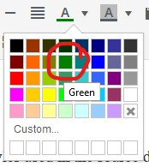
Note that these are similar to the styles used in the source document. The title of the colour selected is the same as the colour is listed in Pressbooks.
- New terms: Red italics.
- Inputs: Bold.
- AutoCAD commands: ALL UPPERCASE
- Inline author comments: Green.
- File names: underlined
Note: The red in Pressbooks isn't dark enough for accessibility. Use it for now, but make sure to use search and replace to change #ff0000 to #ec0000.

Textboxes

Author's Comments
- Select "Standard" from the "Textboxes" menu.
- Put your cursor somewhere inside the textbox.
  - Select the "Apply class" button from the Pressbooks editor (third line of buttons, second button from the left).
  - Type "author" into the "Apply Class" textbox that comes up. Click "OK."
- Insert "AUTHOR'S COMMENTS:" in all caps in the textbox. Bold the text.
- Copy and paste the text as it appears in the source document.
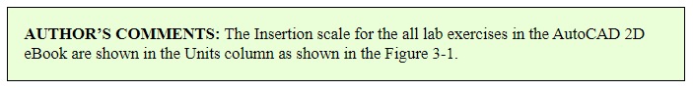

AutoCAD Command
- Select "Examples" from the "Textboxes" menu.
- Edit the textbox heading to read "AutoCAD Command: COMMAND"
- Copy and paste text in as it appears in the source document.
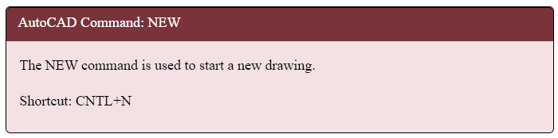

Key Principles
- Select “Key Takeaways” from the “Textboxes” menu.
- Edit the textbox heading to read “Key Principles in Module X.”
- Copy and paste text in as it appears in the source document.
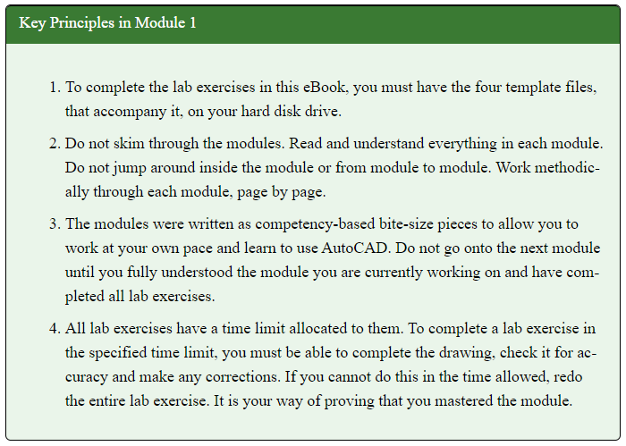

Learning Outcomes
- Select “Learning Objectives” from the “Textboxes” menu
- Edit the textbox heading to read “Learning Outcomes”
- Copy and paste text in as it appears in the source document.
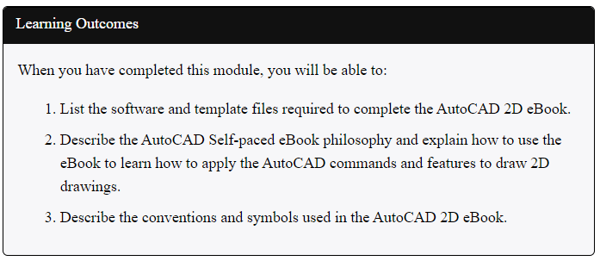

Must Know
- Select “Shaded” from the “Textboxes” menu
- Insert “MUST KNOW:” in all caps in the textbox. Bold the text.
- Copy and paste the text as it appears in the source document
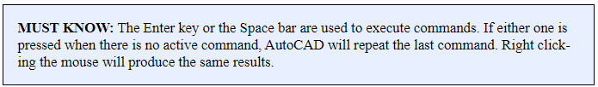

User Tip
- Select “Standard” from the “Textboxes” menu
- Insert “USER TIP:” in all caps in the textbox. Bold the text.
- Copy and paste the text as it appears in the source document.
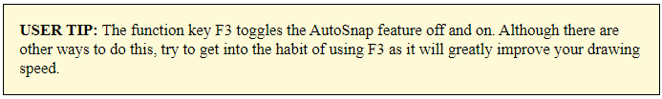

Workalongs
- Use a heading 1 for the following text: WORKALONG: Insert Title of the Workalong
- Each Step starts with a heading 2
- The description of the text begins on the next line in plain text.

Geometry and Drafting Lessons
- Use a heading 1

Lab Exercises
- Use a heading 1 for the following text: Lab Exercise [chapter#]-[exercise#]
- Each Step starts with a heading 2
- Drawing name, template and units are formatted into tables with a header row.
Drawing Name | Template | Units
AutoCAD 2D Lab 04-3 | 2D English | Inches

Custom CSS

Web
/*Reduce padding around textboxes*/
.textbox, .bcc-box {
padding: 1em 1em 1em 1em;
}
.textbox.textbox--learning-objectives .textbox__header, .bcc-box.textbox--learning-objectives .textbox__header {
padding: 0.3em 1em 0.1em 1em;
}
.textbox.textbox--exercises .textbox__header, .bcc-box.textbox--exercises .textbox__header {
padding: 0.3em 1em 0.1em 1em;
}
.textbox.textbox--examples .textbox__header, .bcc-box.textbox--examples .textbox__header {
padding: 0.3em 1em 0.1em 1em;
}
.textbox.textbox--key-takeaways .textbox__header, .bcc-box.textbox--key-takeaways .textbox__header {
padding: 0.3em 1em 0.1em 1em;
}
/*Fix table accessibility/display*/
.front-matter h3, .part h3, .chapter h3, .back-matter h3 {
text-align: left;
}
.front-matter td, .part td, .chapter td, .back-matter td, body#tinymce.wp-editor td {
border: 1px solid;
border-color: #373d3f;
}
.front-matter th, .part th, .chapter th, .back-matter th, body#tinymce.wp-editor th {
border: 1px solid;
border-color: #373d3f;
}
#content table caption {
caption-side: top;
color:#000;
text-align: center; }
/*Standard textbox yellow - User Tips*/
.textbox, .bcc-box {
background-color: #fefad7;
border-color: initial; }
/*Standard textbox green - Author's comments*/
.textbox.author, .bcc-box {
background-color: #eafed7;
border-color: initial; }
/*Shaded textbox blue - Must Know*/
.textbox.shaded, .bcc-box.shaded {
background-color: #e8efff; }
/*Customize headings*/
.front-matter h1, .part h1, .chapter h1, .back-matter h1, body#tinymce.wp-editor h1 {
font-size: 1.1em;
}
.front-matter h2, .part h2, .chapter h2, .back-matter h2 body#tinymce.wp-editor h2 {
font-size: 0.95em;
font-weight: bold;
margin-bottom: 0.5em;
}
h2 + p {
margin-top: 0.5em;
}
.front-matter h3, .part h3, .chapter h3, .back-matter h3, body#tinymce.wp-editor h3 {
font-size: 0.75em;
font-weight: bold;
text-align: left;
margin-bottom: 0.5em;
}
span.comment{
text-align: center;
color: #008000;
font-style: italic;
}
/*move the table caption to the top*/
.front-matter table caption, .part table caption, .chapter table caption, .back-matter table caption, body#tinymce.wp-editor table caption {
caption-side: top;
}

Ebook/PDF
/*Reduce padding around textboxes*/
.textbox, .bcc-box {
padding: 1em 1em 1em 1em;
}
.textbox.textbox--learning-objectives .textbox__header, .bcc-box.textbox--learning-objectives .textbox__header {
padding: 0.3em 1em 0.1em 1em;
}
.textbox.textbox--exercises .textbox__header, .bcc-box.textbox--exercises .textbox__header {
padding: 0.3em 1em 0.1em 1em;
}
.textbox.textbox--examples .textbox__header, .bcc-box.textbox--examples .textbox__header {
padding: 0.3em 1em 0.1em 1em;
}
.textbox.textbox--key-takeaways .textbox__header, .bcc-box.textbox--key-takeaways .textbox__header {
padding: 0.3em 1em 0.1em 1em;
}
/*Fix table accessibility/display*/
.front-matter h3, .part h3, .chapter h3, .back-matter h3 {
text-align: left;
}
.front-matter td, .part td, .chapter td, .back-matter td, body#tinymce.wp-editor td {
border: 1px solid;
border-color: #373d3f;
}
.front-matter th, .part th, .chapter th, .back-matter th, body#tinymce.wp-editor th {
border: 1px solid;
border-color: #373d3f;
}
#content table caption {
caption-side: top;
color:#000;
text-align: center; }
/*Standard textbox yellow - User Tips*/
.textbox, .bcc-box {
background-color: #fefad7;
border-color: initial; }
/*Standard textbox green - Author's comments*/
.textbox.author, .bcc-box {
background-color: #eafed7;
border-color: initial; }
/*Shaded textbox blue - Must Know*/
.textbox.shaded, .bcc-box.shaded {
background-color: #e8efff; }
/*Customize headings*/
.front-matter h1, .part h1, .chapter h1, .back-matter h1, body#tinymce.wp-editor h1 {
font-size: 1.1em;
}
.front-matter h2, .part h2, .chapter h2, .back-matter h2 body#tinymce.wp-editor h2 {
font-size: 0.85em;
font-weight: bold;
margin-bottom: 0.5em;
}
h2 + p {
margin-top: 0.5em;
}
p{
text-align: left;
}
/*Prevents textbox headings being on different pages from their content*/
.textbox__header {
page-break-after: avoid;
}
/*Makes it so centre/right/left-aligned images in the PDF without captions will have text wrap properly*/
img.alignright {
float: right;
margin-left: .5em;
}
img.alignleft {
float: left;
}
img.aligncenter {
display: block;
margin-left: auto;
margin-right: auto; }

