Week 10 – working with sources

Student notes
Welcome to Week 10! Last week, we learned about how to find sources. This week, we're learning how to quote, summarize and paraphrase sources.
This week, please:
- Read Chapter 10a. You'll need this information for your interactive lecture.
- Engage with the interactive lecture. This week's lecture is on ethical citation, how to cite in your blog and how to create an effective link.
- For your participation activity, find an article that offers a different perspective on something you've blogged about. Then, write a paragraph that responds to the article. Make sure to quote/paraphrase at least once.
- For your bonus point, edit the paragraph you wrote about the Jorge J. Rodriquez tweet and post it.
- Watch the video about the textbook makeover project or the final portfolio. You can choose one for your final project.

Participation Activity Forum
For this week's participation activity, we're practicing paraphrasing and summarizing. Using the research skills you learned last week, find an article that offers a different perspective on something you've written about in your blog. For example, if you wrote about a great vacation you had in Kelowna, find an article about someone else's vacation in Kelowna.
Write a paragraph that responds to the article in some way. You must paraphrase or quote at least once. I'll put an example in the forum.
Example:
In this article about pandemic parenting, Deb Perleman writes about how parents are feeling burnt out trying to parent and work at the same time. She says, "We are not burned out because life is hard this year. We are burned out because we are being rolled over by the wheels of an economy that has bafflingly declared working parents inessential." As someone who's currently up past midnight writing this, I definitely appreciated her honesty and her ability to think of the big picture. However, I struggled with the piece's inability to suggest some specific solutions. If school's not safe, and having kids at home isn't working out, what should be done?

Bonus Point Forum
For your bonus point, post the paragraph that you wrote during the interactive lecture about this tweet:
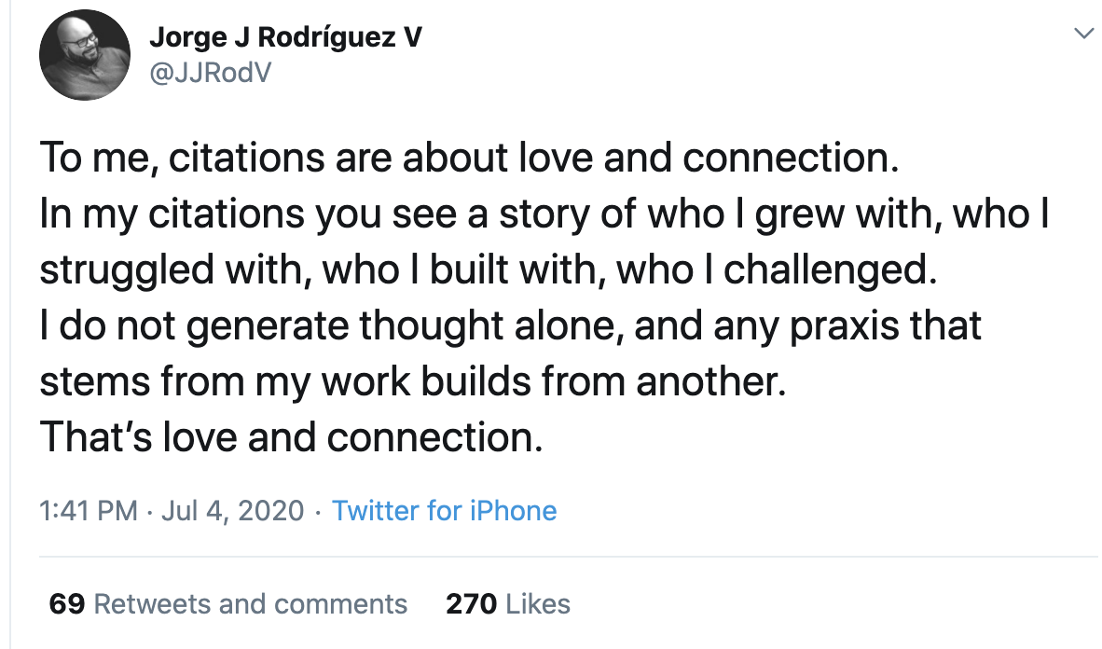
Image description: Tweet from Jorge J Rodriguez V @JJRodV
Text from the tweet: To me, citations are about love and connection. In my citations you see a story of who I grew with, who I struggled with, who I built with, who I challenged. I do not generate thought alone, and any praxis that stems from my work builds from another. That’s love and connection.

