Business Communication OOC
Online Delivery Course Plan

The following document contains a delivery plan for the Business Communication OOC. It’s broken down both by week and by module.

This document is tailored to the learning outcomes of CMNS 1140 (Introduction to Applied Communications at Kwantlen Polytechnic University), but it can be easily adapted to other business communication courses.

The intended audience for this course plan document is the instructor of the course.

Course Learning Outcomes

- Demonstrate understanding of appropriate business communication terminology
- Demonstrate the ability to write clearly and concisely for the workplace using correct grammar, mechanics and syntax
- Identify the differences between academic and business writing
- Understand the basic communication models
- Establish purpose and determine message content, medium and delivery strategy through context and audience analysis
- Adapt message and medium and purpose to a single audience and context, in both traditional and online environments
- Compose the message for the appropriate medium, including online environments
- Write to primary and secondary audiences
- Communicate with diverse audiences.
- Employ fundamental principles of document design and business document conventions to produce a variety of correspondence and reports
- Integrate clear, concise, grammatically-correct language with visual design components
- Illustrate information using a variety of integrated figures and tables
- Research data from primary and secondary sources, and evaluate that data for relevance and accuracy before integrating it with appropriate citations into documents
- Extract, synthesize and summarize essential information from both written and oral sources
- Apply informative and persuasive strategies using direct and indirect approaches to achieve precisely defined goals
- Develop and deliver oral presentations to an audience, within a variety of contexts

Assignments By Learning Outcome

Assignment | 1 | 2 | 3 | 4 | 5 | 6 | 7 | 8 | 9 | 10 | 11 | 12 | 13 | 14 | 15 | 16
Question of the Day | ✅ | ✅ | ✅ |  | ✅ | ✅ | ✅ |  | ✅ |  |  |  |  |  | ✅
Mind Map |  |  |  | ✅ |  |  | ✅ |  |  | ✅ | ✅ | ✅ |  | ✅
Progress Reports | ✅ | ✅ | ✅ | ✅ | ✅ | ✅ |  |  |  | ✅
Blog/Archive Proposal |  | ✅ | ✅ | ✅ | ✅ | ✅ | ✅ |  | ✅ | ✅ |  |  | ✅ |  | ✅
Midterm |  | ✅ |  |  | ✅ | ✅ | ✅ | ✅ | ✅ | ✅ | ✅ |  |  |  | ✅
Blog/Archive Posts |  | ✅ | ✅ | ✅ | ✅ | ✅ | ✅ | ✅ | ✅ | ✅ | ✅ | ✅ | ✅ | ✅ | ✅ | ✅
Cover Letter OR Storytelling Video |  | ✅ |  | ✅ | ✅ | ✅ | ✅ | ✅ | ✅ | ✅ | ✅ |  | ✅ | ✅ | ✅ | ✅
Textbook Analysis Report | ✅ | ✅ | ✅ | ✅ | ✅ | ✅ | ✅ | ✅ |  | ✅ | ✅ | ✅ | ✅ | ✅ | ✅
Portfolio Test | ✅ | ✅ | ✅ | ✅ | ✅ | ✅ | ✅ | ✅ | ✅ | ✅ | ✅ | ✅ | ✅ | ✅ | ✅ | ✅

Assignment Descriptions

Question of the Day  To encourage students to undertake regular, low-stakes writing, students will respond to a daily question posted on Moodle. They will answer 40 per semester, which works out to about 3 per week. | 5%
Progress Reports  To build community, students will be placed into pods of 4 people. Each week, a different student will take turns being a “pod” leader. At the end of the week, they will submit a short progress report about the pod’s activities. They will submit 2 per semester. | 5%
Mind Map  This activity will be done as a group. After each module, pod members will create a mind map that explores connections between the 4 elements of the course (Interactive lecture, readings, Brenda Knights narratives and assignments/activities) and between different modules. Groups will submit 5 per semester (after each module) | 5%
Blog/Archive Proposal  Students will propose what blog or archive they’ll be creating during the semester. To do so, they will demonstrate an understanding of what their audience would be interested in and how to best meet their audience’s needs. | 10%
Midterm  As a midterm, students will exchange a draft of a blog post/ archive piece. They will be graded on the feedback they give, and then the revisions they make to the document in a timed setting. | 15%
Blog Posts/ Archive  Over the course of the semester, students will blog about a topic of interest to them or create an archive of their time during Coronavirus. They will be encouraged to post on a regular basis, then select the best ones to hand in. They will hand in 3 of these blog posts during regular intervals. At least 1 of these must use sources, and cite them effectively. Students will be able to use Wordpress, but they can also submit via Word documents.  Blog Post #1: By Week 6  Blog Post #2: By Week 9  Blog Post #3: By Week 11 | 30%
Cover letter OR Storytelling Video  Students will either write a cover letter tailored to a specific job, or they will create an oral presentation that tells a story that’s meaningful to them. | 10%
Participation  Note: Participation activities will be worth 1 point per week. Bonus will be 0.25. | 10%
Textbook Analysis Report OR Take-Home Test Portfolio  Students can choose to either write a report analyzing the textbook and suggesting ways that it could be improved, or they will revise their work throughout the semester and submit it in a portfolio with a a memo explaining what changes they made and why, and what grade they deserve. | 20%

Course Map
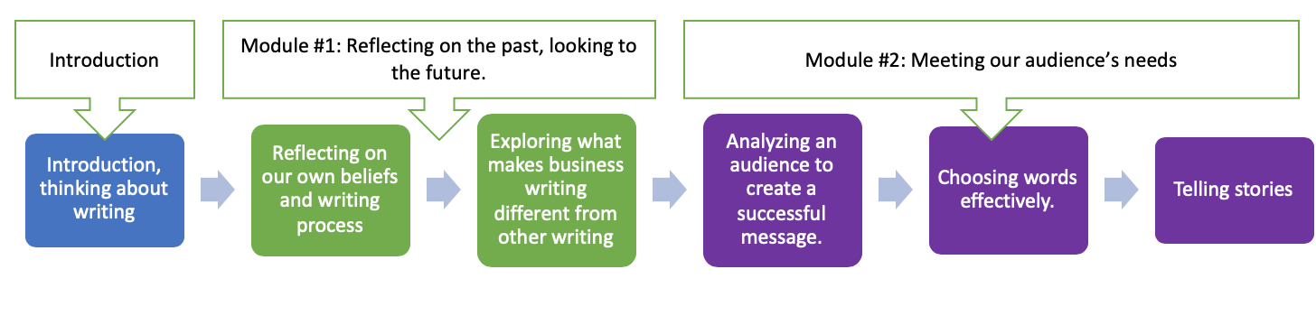
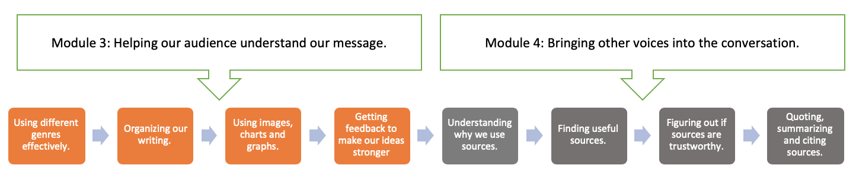
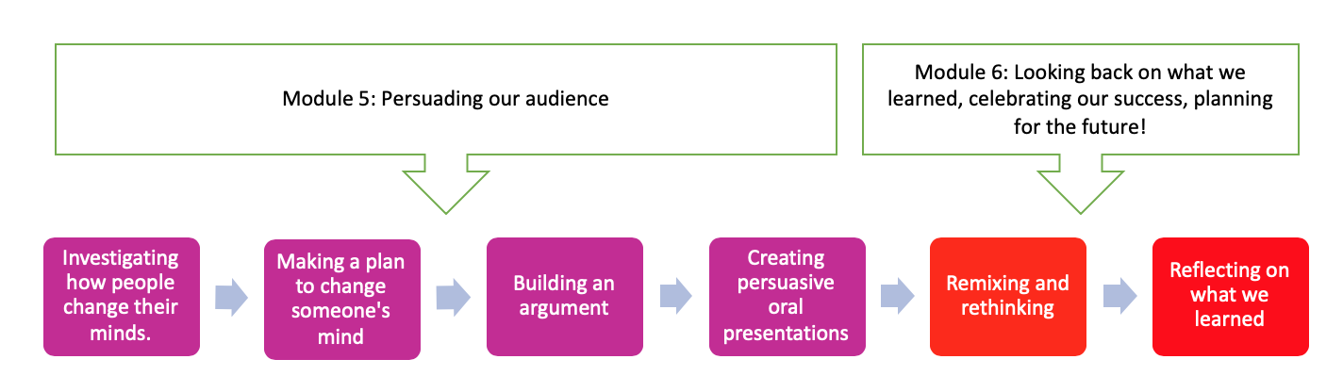

Course Structure

Week 1: Getting to Know You, Thinking About Writing
Learning Outcomes:
- This week is the introduction, so we’re not covering any formal learning outcomes.
Learning Skills
- We will get to know each other and the course.
- We will make our “pods” and set some ground rules.
- We will make important decisions about how our course will go.
- We will learn to use the class Moodle site
Resources
- None, but students will require optional access to a synchronous meeting tool and learning management system (such as Moodle).
Learning Activities
- Class orientation session (creating class charter)
- Class collaborative writing (during orientation session)
- Breakout session with pods: Course presentation and Moodle site scavenger hunt.
Community /Care:
- Reaching out individually to each student to check in.
- Bonus: Have a conversation with one of your pod members, then write a few sentences in the forum introducing them.
Assignments
- Write a paragraph on the topic “what do I need to know about you to help you be successful in this class?” and submit it via Moodle (ungraded)
- Come up with a schedule for pod leaders.

Module #1: Reflecting on the Past, Looking to the Future
WEEK 2
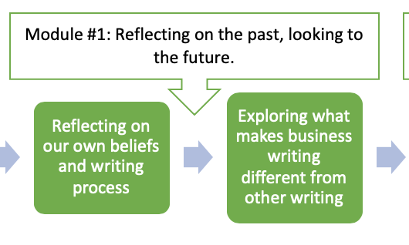
Learning Outcomes:

From the course outline:
- Identify the differences between academic and business writing
- Demonstrate understanding of appropriate business communication terminology

In plain language:
- We will think about how business writing is different from other types of writing
- We will learn some business communication terminology.
Learning Skills
- We will explore our own beliefs, thoughts and feelings about our own writing.
- We will use reflection and critical thinking to examine the “why” of business communication.
- We will understand our own writing process and identify where we might want to make changes.
- We will practice learning online.
- We will continue to develop our classroom community

Resources
- Ch. 1
- Ch. 2
- Bonus: Speaking of Nature by Robin Wall Kimmerer https://orionmagazine.org/article/speaking-of-nature/#.XyQ6wL0O_sI.twitter
- Video explanation of blog proposal assignment
Learning Opportunities
- Interactive lecture on the writing process/ writing beliefs. Students will reflect on their writing beliefs and process.
- Scavenger hunt in pods. Pods will “hunt” for different business documents online and post them in a Splot (you could also use Padlet). They will then do a simple analysis to figure out what the documents they find have in common. Each pod will post in the main forum 1 -2 paragraphs that answer the question: “How is business writing different than academic writing? Why do you think this is?” We’ll use this info in Week 3.
Care/Connection:
- Check in with each student with a personalized response to the paragraph they submitted in week 1.
- Bonus Forum: Try the activity in the Robin Wall Kimmerer article then write a short paragraph about the experience.
Assignments:
- Question of the Day
- 1 student per pod submits a progress report.
- Each pod completes their first mind map.

Module #2: Meeting our Audience’s Needs
WEEK 3, 4, 5
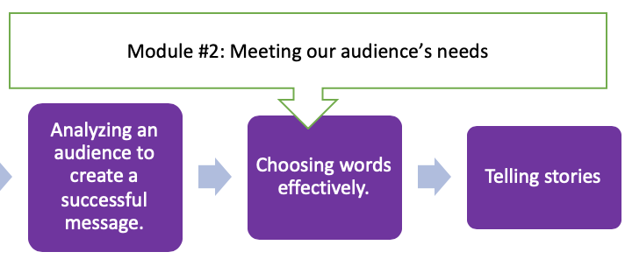
Module Learning Outcomes:

From the course outline:
- Establish purpose and determine message content, medium and delivery strategy through context and audience analysis
- Adapt message and medium and purpose to a single audience and context, in both traditional and online environments
- Write to primary and secondary audiences
- Communicate with diverse audiences.
- Compose the message for the appropriate medium, including online environments
- Demonstrate the ability to write clearly and concisely for the workplace using correct grammar, mechanics and syntax
- Understand the basic communication models

In plain language:
- We will analyze our audience and use this information to create a successful message. We will also consider times when we have more than one audience.
- We will learn some basic communication models to help us with our audience analysis.
- We will explore intercultural communication and identify our own values.
- We will practice using plain language to make our messages accessible.
- We will think about how the decisions we make as writers create the “tone” of the piece, and choose this tone intentionally.
- We will explore storytelling and consider how telling stories can help us create more effective business messages.
Learning Skills
- We will come up with an idea for a blog or archive project.
- We will learn to use Wordpress or choose another medium for a blog/ archive project.
- We will work together on low-stakes projects as a group.
- We will practice reading assignment prompts.
Assignments:
- Question of the Day
- 1 student per pod per week submits a progress report.
- Blog proposal

Week 3: Analyzing an audience to create a successful message
Resources
- Ch. 3
- What is a blog? Video
- Instructions on how to set up a Wordpress blog (https://www.youtube.com/watch?v=NjwUHXoi8lM)
Learning Opportunities
- Interactive H5P lecture on audience analysis that focuses on miscommunication.
- Participation activity: For this week's participation activity, you'll apply the CMAPP model to your blog or Coronavirus archive. I'll post an example in the forum.
- Short video giving an overview of the module.
Care/Connection:
- Bonus forum: Practice your audience analysis skills by sharing something that you think will make your classmates happy.
Assignments:
- Question of the Day
- 1 student per pod submits a progress report.

Week 4: Choosing Words Effectively
Resources
- Ch. 4
- Optional: Read "Garbage Language: Why Do Corporations Speak The Way They Do?"
Learning Opportunities
- Interactive lecture on plain language and style and tone where students will be asked to edit a piece of work. We will also reflect on the political implications of tone and explore how active/passive voice works in BLM-related headings.
- Either “Capture a Mood” activity (pick a mood and describe your room in a way that reflects that mood, then guess someone else’s mood) OR Identify ways that this ineffective version of Assignment #1 makes some style and tone mistakes.
Care/Connection:
- Give feedback about blog/archive projects.
- Bonus point: Bulwar-Lytton competition. The “prize” for the Bulwar-Lytton competition will be a badly drawn picture of a trophy or something equally silly.
- First feedback survey
Assignments:
- Question of the Day
- 1 student per pod submits a progress report.
- Blog/Archive Proposal DUE

Week 5: Telling Stories
Resources
- The Danger of a Single Story Ted Talk
- Spreadsheet where students can put in the URLs of their blogs, so we can keep track of each other’s blogs.
- Video about midterm
Learning Opportunities
- Possibly Microsoft Teams visit with Indigenous Elder.
- Interactive H5P lecture about models of stories, asking students to reflect on intercultural experiences with storytelling
- Collective storytelling activity. Each pod will get a Wiki. One group member write the first few lines of a story, then the next group member will take over. Each participant must write at least twice. After, pods will post their final stories in the main forum.
Care/Connection:
- Send out feedback surveys.
- Bonus point activity: Our reading was about the danger of a single story. For your bonus point, write about a time when someone created an overly simple story about you. How could you use your blog to tell a different story?
Or
- Talk to an elder in your life and ask them to tell a story. You don’t have to write down the story, but write a paragraph about that experience.
Assignments:
- Question of the Day
- 1 student per pod submits a progress report.

Module #3: Helping our audience understand the message
WEEK 6, 7, 8
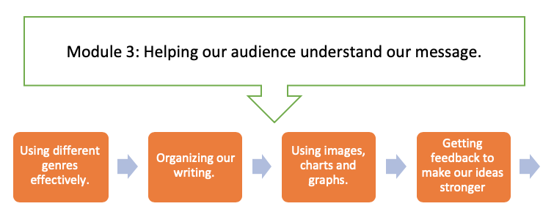
Learning Outcomes:

From the course outline:
- Apply informative and persuasive strategies using direct and indirect approaches to achieve precisely defined goals
- Employ fundamental principles of document design and business document conventions to produce a variety of correspondence and reports
- Compose the message for the appropriate medium, including online environments
- Integrate clear, concise, grammatically-correct language with visual design components
- Illustrate information using a variety of integrated figures and tables

In plain language:
- We will learn how to be successful in different genres, like emails, memos and letters.
- We will learn how to use the communication models we’ve learned to pick a medium.
- We will think about how to organize our work so that our audience can find our most important points.
- We will explore the role that images, charts and graphs can play in helping a reader understand information.
- We will use the audience analysis and tone skills we’ve already acquired to give feedback.

Learning Skills
- We will get a little practice in writing under pressure.
- We will work on our blog/archives
Assignments:
- Question of the Day
- 1 student per pod per week submits a progress report
- At least one blog/archive post
- “Midterm”

Week 6: Working with different workplace genres
Resources
- Ch. 6
- Brief module intro video
Learning Opportunities
- Interactive lecture building on the readings, reinforcing CMAPP, and showing some genres in action.
- Participation activity: Working in your pods, write an email/memo/letter that responds to the scenario in your document. When you're done, post your completed email in the forum. Then, write some feedback about another group's email/memo/letter and post it to the forum.
- Video explaining blogging/archive project more thoroughly.
Care/Connection:

- Video grading for 1st big assignment
- Bonus point: for your bonus point, you have two options: 1) Read this article about Dr. Bonnie Henry's communication style. Then, write a paragraph about how you can apply what you read to your business communication practices. 2) Leave a comment on a classmate's blog.
Assignments:
- Question of the Day
- 1 student per pod submits a progress report

Week 7: Organizing Our Writing, Using Images, Charts and Graphs
Resources
- Ch. 5
- Ch. 12

Learning Opportunities
- Interactive lecture building on the readings, asking students to think about how visuals and informational aids can help readers understand more easily.
- Working in their pods, students will complete a Gestalt Theory scavenger hunt, where they’ll scour the web (or their own homes) for different Gestalt principles.
- Video explaining the “midterm”

Note: at this point in the semester students are generally feeling overwhelmed by other midterms, so this week does not contain an interactive lesson. It’s designed to be a bit of a catch-up week. Instead the participation activity was:
Pick one concept that you learned about in one of those 2 chapters that you’ve read this week. Then, either:
- make a visual (chart, graph, infographic, etc) that teaches your classmates about the topic OR
- use what you learned about paragraphs to write a clear paragraph that summarizes the topic.
Care/Connection:
- Extra office hours, since blog posts are due.
- Bonus point: for your bonus point call up someone in the class (or another friend) and read a blog post to them. Get feedback. Write a few sentences in the forum about how that felt.
Assignments:
- Question of the Day
- 1 student per pod submits a progress report.
- First blog post due.

Week 8: Getting Feedback to Make Our Work Stronger
Resources
- Ch. 16

Learning Opportunities
- The interactive lecture was about listening to feedback and making room for other perspectives. Some of this was adapted from the BCCampus Pulling Together Guide for Educators.
- Participation activity: Your interactive lecture is about different types of listening. When you open your group's folder, you will see a scenario. Write a script (or make an audio/video recording) where both participants use generative listening to give and receive feedback. When you're done, post your script in the participation activity forum.

Care/Connection:
- Feedback on first blog post.
- Bonus point: for your bonus point try one of the revision activities and write about how it went.
Assignments:
- Question of the Day
- 1 student per pod submits a progress report.

Module #4: Bringing Other Voices Into the Conversation
WEEK 9, 10
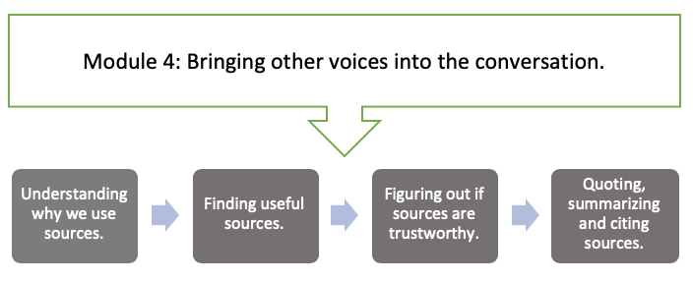
Learning Outcomes:

From the course outline:
- Research data from primary and secondary sources, and evaluate that data for relevance and accuracy before integrating it with appropriate citations into documents
- Extract, synthesize and summarize essential information from both written and oral sources
- Apply informative and persuasive strategies using direct and indirect approaches to achieve precisely defined goals

In plain language:
- We will explore why we use sources.
- We will find useful primary and secondary sources.
- We will analyze sources to determine their trustworthiness.
- We will integrate sources into our writing by quoting, paraphrasing and summarizing.
- We will give credit by citing our sources effectively.
- We will use these sources to create an argument.

Learning Skills
- We will continue to refine our peer workshopping skills.
- We will explore how source use is culturally determined and discuss our source use values.
Assignments:
- Question of the Day.
- 1 student per pod per week submits a progress report.
- At least one blog/archive post.

Week 9: Finding and Evaluating Sources
Resources
- Ch. 9
Learning Opportunities
- Anonymous forum for students to submit questions about source use.
- Instead of developing an interactive lecture, I had students go through the "Sifting Through the Pandemic" micro lesson created by Mike Caulfield. This lesson was developed to help students evaluate sources about COVID-19.
- Source scavenger hunt in pods.
Care/Connection:
- Bonus point: for your bonus point go for a walk and practice the listening skills we learned last week. If you don't want to take a walk, do some other form of self care. Then, write a few sentences about it.
Assignments:
- Question of the Day
- 1 student per pod submits a progress report.
- Midterm

Week 10: Working with Sources
Resources
- Ch.10a

Learning Opportunities
- Anonymous forum for students to submit questions about source use.
- Interactive source use lecture where students will practice citing, quoting and summarizing.
- In a discussion forum, students will pick an article they’re interested in and find one great quote, and then summarize the main points.
- I will post the video about the final portfolio/ textbook analysis assignment in this week.
Care/Connection:
- Video responses to midterms.
- Bonus point: for your bonus point, post the paragraph that you wrote during the interactive lecture about the J.R tweet example that is provided in the interactive lecture.
Assignments:
- Question of the Day
- 1 student per pod submits a progress report.

Module #5: Persuading Our Audience
WEEK 11, 12
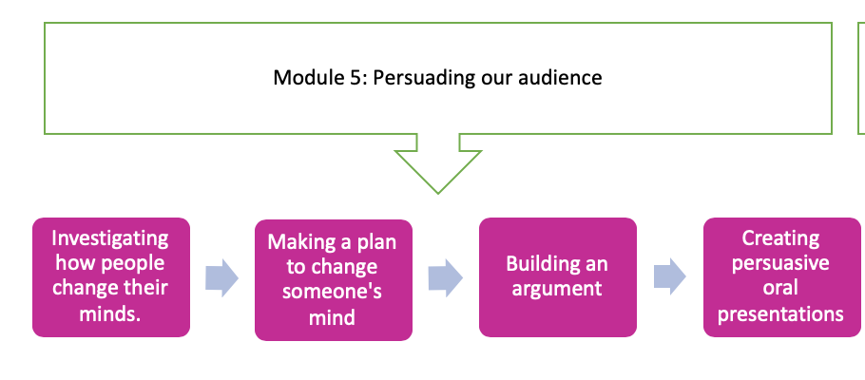
Learning Outcomes:

From the course outline:
- Research data from primary and secondary sources, and evaluate that data for relevance and accuracy before integrating it with appropriate citations into documents
- Extract, synthesize and summarize essential information from both written and oral sources
- Apply informative and persuasive strategies using direct and indirect approaches to achieve precisely defined goals
- Develop and deliver oral presentations to an audience, within a variety of contexts

In plain language:
- We will investigate how people change their minds.
- We will develop a strategy to change someone’s mind.
- We will build on the citation and source use skills we learned to build an argument.
- We will build on the storytelling and persuasion skills we learned to create engaging oral presentations.

Learning Skills:
- We will learn how to find job postings and read them effectively.
- We will think about the unique contributions we make as employees.
Assignments:
- Question of the Day
- 1 student per pod per week submits a progress report.
- Cover letter OR storytelling assignment

Week 11: How to change someone’s mind
Readings
- Ch.8

Learning Opportunities
- Very short video overview of the module.
- Overview of the cover letter assignment and storytelling assignment.
- Interactive lecture on persuasion that focuses on job application materials
- Activity: Be the hiring manager.
Care/Connection:
- Video responses to assignments.
- Bonus: Tell the class about a time when you changed your mind on something. How did it happen? What made you change your mind?
Assignments:
- Question of the Day
- 1 student per pod submits a progress report.

Week 12: Making An Argument and Oral Presentations
Readings
- Ch.13 OR Ch. 10b

Learning Opportunities
- Interactive lecture about making an argument in writing and in person.
- 1 Minute Oscars: You’ll have 1 minute to make your audience care about something you’re passionate about. We’ll give the CMNS 1140 “Oscar” to the person we thought was most passionate/interesting.
Care/Connection:
- Check in with students to see how the end of the semester is going.
- Bonus: This week, you had a choice in your readings. Post notes for your reading, so that those who read the other chapter can benefit.
Assignments:
- Question of the Day
- 1 student per pod submits a progress report.
- Cover letter OR storytelling video due

Module #6: Looking back on what we learned, celebrating our success
WEEK 13
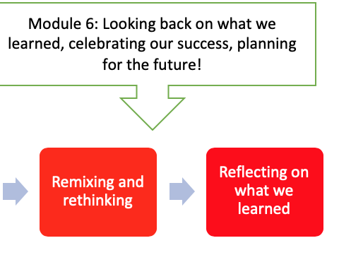
Learning Outcomes:
- We will review learning outcomes from the whole semester.
Learning Skills
- We will celebrate our successes!
- We will look back on what we learned.
- We will think about revision, remixing and rethinking.
- We will look ahead to the future.

Assignments:
- Question of the Day.
- 1 student per pod per week submits a final progress report.
- Portfolio or final report.

Learning Opportunities
- Everything is a Remix Video
- Short goodbye/ wrap up/ next steps lecture
- Final activity: Write a letter to someone who is taking CMNS 1140 for the first time and tell them what they need to know to be successful in the course.
Care/Connection:
- Thank each student personally.
- Bonus: Share something you admire about each of your pod-mates.

