Business Communications
Course Syllabus

Instructor: [Name] (preferred pronouns)

Course dates:
Online Orientation Session
Final Day To Submit Materials
Email Address:

[Insert Indigenous Territorial Land Acknowledgement for your region]

Course Description
Welcome to our course! I’m so glad that you’re here. I can’t wait to read your writing, hear your ideas and get to know you. Even though this class was intended to be online from the start, we’re living through an unprecedented moment in human history. COVID-19 is probably using up a lot of your brain space right now. It’s using up a lot of my brain space too.
So, we are going to do the best we can together. I will share with you what I have learned about writing across my various careers as a novelist, marketing and communications manager and writing teacher. I hope that you will share with me what you know about communicating.

This course will follow these guiding principles:
- This is our class, not my class. During our orientation, we will build our class culture together. If something’s not working, we’ll change it. If you have a great idea for an activity, share it with me.
- I will give you choice. In each assignment, you’ll have some options for how to show your learning. And if you’re not interested in any of those options, let’s talk. The more interested you are in this course, the better you’ll do.
- Community is as important as content. A lot of research shows that a student’s connection with their instructor and their classmates is the #1 predictor of success in a class. Online classes can feel isolating, so I have tried my best to build in community. We’ll decide together what that community looks like.
- We will be flexible. I’ve tried to build flexibility into this course, but there is room for more. Your timeline might not look like your classmate’s timeline, and that’s okay.
- We will do work that we’re proud of. I want you to do assignments that you’re excited to show your friends and that you think about after the class is over. I will try to give you a real-life audience. But again: if you have an idea for a project, come and talk to me.
- We’ll focus on process, not product. To be a good writer, you need to take risks and constantly plan, write and revise. This course is set up to give you lots of opportunities to try again. You’ll get regular feedback and you can make changes based on what you’ve learned. You can revise and resubmit assignments, for example. I hope to dial down the grade pressure, since grades have been shown to negatively impact learning.

Learning Outcomes

- Demonstrate understanding of appropriate business communication terminology
- Demonstrate the ability to write clearly and concisely for the workplace using correct grammar, mechanics and syntax
- Identify the differences between academic and business writing
- Understand the basic communication models
- Establish purpose and determine message content, medium and delivery strategy through context and audience analysis
- Adapt message and medium and purpose to a single audience and context, in both traditional and online environments
- Compose the message for the appropriate medium, including online environments
- Write to primary and secondary audiences
- Communicate with diverse audiences
- Employ fundamental principles of document design and business document conventions to produce a variety of correspondence and reports
- Integrate clear, concise, grammatically-correct language with visual design components
- Illustrate information using a variety of integrated figures and tables
- Research data from primary and secondary sources, and evaluate that data for relevance and accuracy before integrating it with appropriate citations into documents
- Extract, synthesize and summarize essential information from both written and oral sources
- Apply informative and persuasive strategies using direct and indirect approaches to achieve precisely defined goals
- Develop and deliver oral presentations to an audience, within a variety of contexts

Required Texts
To battle the rising costs of textbooks, we will use open source texts in this class. I will post the readings on our course site each week. You can also access the textbook at: https://kpu.pressbooks.pub/businesswriting/

Contacting Me
Email is the best way to reach me. I will respond to your email as quickly as possible. Please email me at [email address]
In general, online courses work best when there’s a lot of communication between student and instructor. We can work together and come up with a solution for nearly every problem.

Office Hours

[Insert details here including the preferred method to meet (e.g. Zoom, institutional platform, Phone, etc.]. We will decide a time that works for most people during our orientation. You don’t have to make an appointment to show up at my office hours.

If you’d like to meet with me outside of my office hours, just email me and we’ll set up a time.

Also, before assignments are due, we will have a writing party. You can sign on any time during the 2-hour time slot. We’ll just work on our assignments together, and you can ask me questions when you have them as you work.

Assignments
These assignments are set up to reward your process, not your product. That means that you’ll have lots of opportunities to try again, and you’ll be rewarded for taking risks, even if those risks don’t pay off. Many assignments are also participation-based. If you do the work, you’ll get the points. And there will be many opportunities for bonus points along the way. You’re also welcome to revise your assignments to get a higher grade.

To say it simply: I want you to do well, and there are many opportunities for you to do your best work.

Assignment Name | Due Date | %
Question of the Day  This is a participation exercise designed to help build community and give you practice in writing on a regular basis. From Monday to Friday, I’ll post a question in a discussion forum. For each question you answer, you get 1 point. You must answer 40 per semester, which works out to about 3 per week. | Weekly | 10%
Progress Reports  To build community, you will be placed into pods of 4 people. Each week, a different student will take turns being a “pod” leader. At the end of the week, they will submit a very short progress report about the pod’s activities. You will submit 2 per semester. | Sign up twice a semester. | 5%
Blog/Archive Proposal  This semester, you’ll have the choice of creating a blog or making an archive of your life during Coronavirus. In this assignment, you’ll write an email proposing what you plan to create. | Hand in by [deadline] | 10%
Midterm  For your midterm, you will exchange a draft of a blog post/ archive piece with a partner. You will be graded on the feedback you give, and then the revisions you make to your draft. | Complete by [deadline] | 15%
Blog Posts/ Archive  Over the course of the semester, you will blog about a topic of interest to them or create an archive of your time during Coronavirus. You will be encouraged to post on a regular basis, then select the best ones to hand in. You will hand in 3 of these blog posts during regular intervals. At least 1 of these must use sources, and cite them effectively. You will be able to use Wordpress (publicly or privately) or you can create your archives in a Word document.  Blog Post #1: By [deadline]  Blog Post #2: By [deadline]  Blog Post #3: By [deadline] | Blog post #1 [deadline]  Blog post #2 by [deadline]  Blog post #3  By [deadline] | 30%
Cover letter OR Storytelling Video  You will either write a cover letter tailored to a specific job, or you will create an oral presentation that tells a story that’s meaningful to you. | Hand in by [deadline] | 10%
Participation  Note: Participation activities will be worth 1 point per week. Bonus will be 0.25. | Weekly | 10%
Textbook Analysis Report OR Take-Home Test Portfolio  You can choose to either write a report analyzing the textbook and suggesting ways that it could be improved, or you can revise your work throughout the semester and submit it in a portfolio with a memo explaining what changes you made and why, and what grade you deserve. | [deadline] | 20%

Extension Policy

Handing in assignments by the deadlines will help me give you timely feedback. However, life happens. If you need more time, simply ask. You don’t need to tell me why you need an extension. If you have an extension, it may take me a little longer to give you feedback because I might be grading papers for other classes.

Language Use
Grammar and sentence mechanics are important, but they’re just one part of the writing process. Often, grammar causes students a lot of stress, and seeing a page full of corrections can be demoralizing.

My goal is to help you write as clearly and effectively as possible within the workplace. When I read your writing, I am mostly looking for clarity. If I notice that you’ve made the same grammar error a few times, I will point out an example in your work and send you a link to a resource that shows you how to fix the error. If you correct the errors and send the assignment back to me, I will re-mark the “Style and Tone” section of your assignment. If you have concerns about your grammar, please come and see me. We can work on your grammar together.

Throughout the semester, I’ll also discuss how you can make your writing clearer and more effective.

Course Set Up

This course is created so that you can work at your own pace. This course is set up into small chunks called modules, which are themed around a topic. The modules will take you 1 - 3 weeks to complete, and you can work at your own pace. So, if the module takes 3 weeks, you can complete it all in 1 week, or you can use the full 3 weeks. The modules are all listed on the tabs at the top of the course site, and everything you need to complete the module will be on that page.

Except for our first class, which will be through [course delivery method], this course will be asynchronous, which means that we won’t be meeting at a regular time.

You can also hand in assignments at your own pace. To improve your writing, you’ll need regular feedback. I’ve set up due dates, but these are flexible. Just make sure that you talk to me first if you want to hand in work after the due date.

This course map shows you how the modules will fit together.

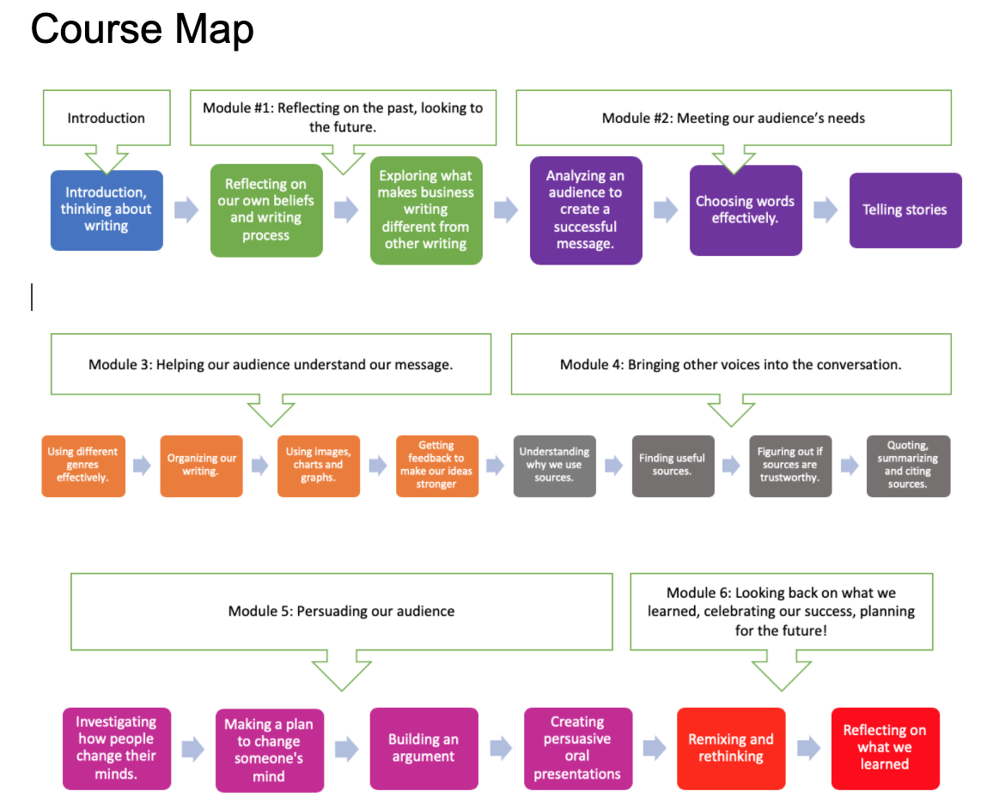

Weekly Chart
Track your progress with this weekly chart.

Week | Dates | Module | Topic
Week 1 |  | Introduction | Introduction/ Orientation
Week 2 |  | Reflecting On the Past, Looking to the Future | Writing beliefs/ writing process/ what is business communication?
Week 3 |  | Meeting Our Audience’s Needs | Audience Analysis
Week 4 |  | Meeting Our Audience’s Needs | Choosing Words Effectively  Hand in Blog Proposal by [deadline]
Week 5 |  | Meeting Our Audience’s Needs | Telling Stories
Week 6 |  | Helping Our Audience Understand the Message | Choosing Workplace Genres
Week 7 |  | Helping Our Audience Understand the Message | Organizing Our Writing  Hand in blog post #1 by [deadline]
Week 8 |  | Helping Our Audience Understand the Message | Giving and Receiving Feedback
Week 9 |  | Bringing Other Voices Into the Conversation | Finding and Evaluating Sources  Hand in midterm by [deadline]
Week 10 |  | Bringing Other Voices Into the Conversation | Working with Sources  Hand in blog post #2 by [deadline]
Week 11 |  | Persuading Our Audience | How to Change Someone’s Mind
Week 12 |  | Persuading Our Audience | Working With Sources to Create An Argument  Hand in Blog post #3 by [deadline]
Week 13 |  | Looking Back on What We Learned/ Celebrating Our Success | Hand in cover letter or storytelling video by [deadline]  Textbook Analysis Report OR Take-Home Test Portfolio by [deadline]

About the Pods

Online courses can feel lonely. While all assignments are individual, you’ll be placed in a pod of 4 - 5 people. You’ll work on participation activities with them, and check in with them regularly. This semester, you’ll be the weekly pod leader twice. At the end of the week, you’ll submit a very short progress report (using online quizzes) that tells me what your pod is working on this week. You can also let me know what questions you have, and if you’re encountering any problems. This will let me address your questions and make sure everyone’s on track.

Academic Integrity Policy

This class teaches how to use sources, so we’ll talk a lot about academic integrity. I approach most academic integrity violations as opportunities to learn. If I find evidence of improper source use in your work, I will ask to meet with you and you will be required to revise your work. In rare cases, such as when I find evidence of ghostwriting, I may pursue formal plagiarism charges. Please familiarize yourself with [link to your institution’s academic integrity policy]

Student Conduct Policy
The University ascribes to the highest standards of conduct. Adhering to these standards of conduct means observing the values on which an academic community must be founded: respect, safety, civility, inclusiveness, and freedom from harassment and discrimination. Students are expected to conduct themselves in a manner that is consistent with these values. These standards of conduct require that Students obey the law, be aware of and abide by University policies, behave in a safe and civil manner, demonstrate respect for members of the University’s community, and demonstrate respect for the University’s and its community members’ property and resources.

To learn more, please read the [link to your institution’s student conduct policy]

Diversity and Inclusion Policy

We will work hard to build a classroom community that works for everyone. Please familiarize yourself with [link to your institution’s diversity and inclusion policy]

