Sample Assignment Package

Business Communications Assignment Package Overview 3
Progress Report Assignment 5
Assignment Goals 5
Instructions 5
Rubric 5
Group Report Progress Report Template 7
Mindmap Activity 8
Assignment Goals 8
Instructions 8
Rubric 10
Blog/Archive Proposal 10
Assignment Goals 10
Instructions 11
Rubric 12
Midterm 14
Assignment Goals 14
Instructions 14
Rubric 15
Blog Posts / Coronavirus Archive 16
Instructions 16
Rubric 17
Resume and Cover Letter 18
Assignment Goals 18
Instructions 18
Rubric 19
Storytelling Video 20
Assignment Goals 20
Instructions 20
Rubric 21
Portfolio Project 22
Assignment Goals 22
Instructions 22
Rubric 23
Textbook Makeover 24
Instructions 24
Rubric 25

Business Communications Assignment Package Overview
This document contains all of the assignment prompts for this course.

Assignment Name | Due Date | %
Question of the Day  This is a participation exercise designed to help build community and give you practice in writing on a regular basis. From Monday to Friday, I’ll post a question in a discussion forum. For each question you answer, you get 1 point. You must answer 40 per semester, which works out to about 3 per week. | Weekly
Progress Reports  To build community, you will be placed into pods of 4 people. Each week, a different student will take turns being a “pod” leader. At the end of the week, you will submit a very short progress report about the pod’s activities. You will submit 2 per semester. | Sign up twice a semester.
Mindmap Activity

Blog/Archive Proposal
This semester, you’ll have the choice of creating a blog or making an archive of your life during Coronavirus. In this assignment, you’ll write an email proposing what you plan to create.
Midterm  For your midterm, you will exchange a draft of a blog post/ archive piece with a partner. You will be graded on the feedback you give, and then the revisions you make to your draft. | Complete by [Deadline] | 15%
Blog Posts/ Archive  Over the course of the semester, you will blog about a topic of interest or create an archive of your time during Coronavirus. You will be encouraged to post on a regular basis, then select the best ones to hand in. You will hand in 3 of these blog posts during regular intervals. At least 1 of these must use sources, and cite them effectively. You will be able to use Wordpress (publicly or privately) or you can create your archives in a Word document.  Blog Post #1: By [Deadline]  Blog Post #2: By [Deadline]  Blog Post #3: By [Deadline] | Blog post #1 by [Deadline]  Blog post #2 by [Deadline]  Blog post #3  By [Deadline] | 30%
Cover letter/Resume OR Storytelling Video  You will either write a cover letter tailored to a specific job, or you will create an oral presentation that tells a story that’s meaningful to you. | Hand in by [Deadline] | 10%
Participation  Note: Participation activities will be worth 1 point per week. Bonus will be 0.25. | Weekly | 10%
Textbook Analysis Report OR Take-Home Test Portfolio  You can choose to either write a report analyzing the textbook and suggesting ways that it could be improved, or you can revise your work throughout the semester and submit it in a portfolio with a memo explaining what changes you made and why, and what grade you deserve. | [Deadline] | 20%

Progress Report Assignment
Due: Twice per semester (see sign-up sheet)

In the first week of class, you’ll be placed in accountability pods. Each week, a different person will be the Team Lead. You can sign up on the class Moodle site. In your week as Team Lead, you will be responsible for writing a short progress report. The template for the report is below.

Assignment Goals
- To practice concision and plain language. Short reports are meant to be read quickly, so it’s important that you are clear and concise.
· To meet an audience’s needs. In a short space, you must tell me what I need to know in a way that is easy for me to understand.
· To synthesize information from a variety of sources. You’ll need to check in with each group member and detail their progress and their concerns. Practicing in this small way will make it easier for us to synthesize our sources later in the semester.

Instructions
1. Read the template (below). You can copy and paste it into a document of your choice, or you can download it on its own in a variety of formats on Moodle.
2. During your week as Team Lead, take notes about what your group accomplished. For example, you might say, “We worked together on the participation activity. We also texted with each other about questions we had about the assignment. Ravi visited your office hours to get our questions answered, then reported back to the group. We also commented on each other’s blogs.”
3. At the end of the week, connect with each of your group members and ask what questions/concerns they have. Try to contact the group members at least twice. If they don’t respond, write this in the report.
4. Write your progress report and edit it for concision and grammatical correctness.
6. Hand in your progress report in Moodle by Sunday night.

Rubric
Completeness – /50
· Did you fill out every section? Did you give specific examples of your group’s progress?
· Was each question concise?
· Did you reach out to each group member?
· Did you give me a sense of what each group member accomplished?
· Have you given me the information I need to help your group succeed?
Correctness - /20
· Is your report correct? Is it fair to your group members?
· Is your report free of spelling and grammar errors?
Audience Analysis - /30
· Does your report meet my needs by helping me understand how your group did this week?
· Have you used a positive tone that is helpful to me? For example, saying “Our group is confused” wouldn’t be helpful, but “Our group needs help learning how to cite our work” would be helpful.
· Is your report easy to read? Have you used the plain language principles we discussed?

Group Report Progress Report Template
Name:
Date:
Group Name:
1. What did your group accomplish this week? Be as specific as possible.

2. What did your group do well?

3. What challenges did your group face?

4. How did your group communicate with each other? Could anything improve your communication?

5. Is there anything else that I should be aware of?

Mindmap Activity

Assignment Goals
In this activity, you will:
- Make connections between the topics we explore in this class;
- Discuss and develop the concepts in this course with your group members to deepen your knowledge;
- Practice writing and working collaboratively with your group;
- Hopefully think about the ideas in this class in a new way.

Instructions
As a group, you will be creating a giant mind map of your experience over the semester. A mind map is a way to connect items visually. It’s meant to represent the way that we see ideas connected to each other and the way we associate ideas and events. For example, if you think of the word DOCTOR and the fear of needles jumps into your mind, that’s a mind map! The idea of NURSE and WAITING ROOM might also jump into your mind – that's expanding your mind map.

Each module’s mind map will address 5 areas:
- The interactive lectures;
- The readings;
- The participation activities and assignments;
- The Brenda Knights narratives in your textbook;
- Unanswered questions

Here is an example of a potential mind map for Module #1:
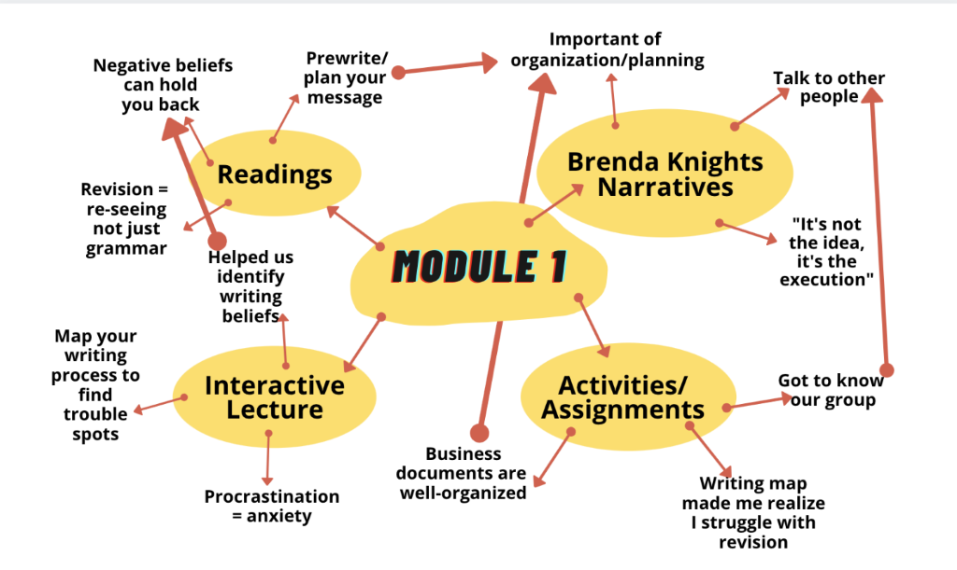
In this example, the writer has found connections between different parts of the first module.
You don’t have to address absolutely everything we covered during the module. The goal is to pick out points that stood out for you and your group and make connections between the 4 aspects of the course and between different modules.

This example shows someone making connections between Module #1 and Module #2.
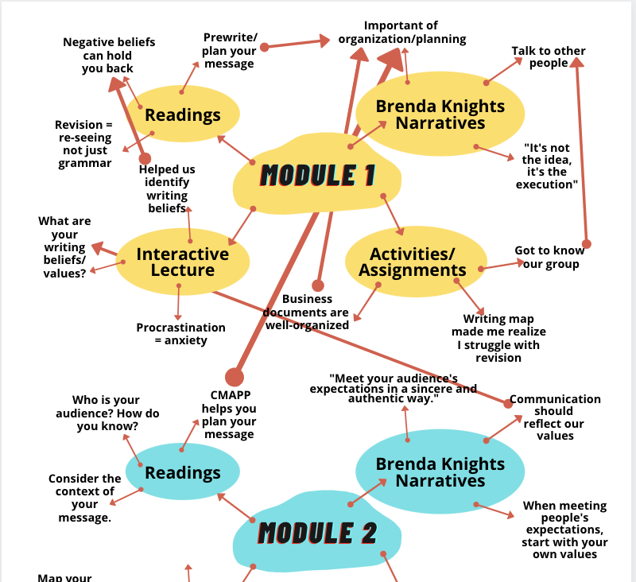

Again, what’s important here is that the mind map shows visually the connections between the first and the second module.

Mindmap Format
You can choose to make your mindmap in whatever format you want. The example was made in Canva, but you can use chart paper, use many small pieces of paper and attach them together, or you create a collaborative writing document (OneDrive, Google Docs, etc). You can elect one person to be the “scribe” and draw the mindmap based on everyone’s input, you can change “scribes” every week, or you can all work on one (digital) document. This activity is probably easiest to do synchronously, but if you’re working in a digital document, it can be done asynchronously.

Remember: you’re being graded on your ability to find connections, not on your grammatical correctness, artistic abilities etc.

Your mind map will be due at the beginning of the next module. So, module #2’s mind map will be due at the beginning of module #3. Please hand in either a picture of your physical mind map or a copy of your digital map into the course Moodle site.

Rubric

Criteria | 5 points | 2.5 points | 0 points
Completeness | The group’s mind map included all 4 parts of the course (Brenda Knights narrative, readings, interactive lecture, activities and assignments). The group picked out at least 2 themes for each of the 4 parts. | The group’s mind map was missing at least 1 part of the module, or the group didn’t find at least 2 themes for 1 of the parts. | The group did not hand in the mindmap or did not identify any themes for any of the 4 parts.
Connections | The group found more than one connection between parts of the module, or between different modules. The reader could understand why the group made these connections. | The group found 1 connection between parts of the module or between different modules. Some of the connections might not be clear. | The group did not find connections between the parts of the module or between different modules.
Clarity | The group’s mindmap was easy to read. | Parts of the group’s mind map were confusing or illegible. | Much of the group’s mind map was confusing or illegible.

Blog/Archive Proposal

Assignment Goals
This assignment will give you practice in the following skills:
- How to consider an audience’s needs.
- How to write a clear and concise email.
- How to use clear paragraphs and headings.
- How to use plain language and appropriate grammar in a business context.

Instructions
This semester, we’re going to be blogging. You will have two options:
- Creating an archive of your life during COVID-19. In the future, historians will want to know what this moment was like. You’ll help out future historians by keeping a journal of your daily life. You’ll include photos and even use sources. Remember: you don’t actually have to make your journal public.
- Creating a blog about a topic you’re interested in. Maybe you’re sick of thinking about COVID-19! If so, you can create a blog about a topic that you’re passionate about. There are a lot of blogs in the world, so you’ll want to have a narrow focus and be useful to your reader. For example, there are tons of restaurant review blogs/podcasts, but maybe you create a blog aimed to boost traffic to local restaurants by reviewing their takeout. Or maybe you create a blog devoted to recreating old recipes from your grandma’s cookbook.

The project’s criteria has been kept broad to allow you to pursue your interests and to make sure that you can be successful no matter your circumstances. You could:
- Create a scrapbook that merges writing about what you’re doing over the next few weeks with images and drawings. (You could do this on paper and send me photos, or you could do this in an online format).
- Write a series of letters to historians in the future, or to someone you care about. For example, if you live far away from your parents, you might choose to write them letters about what your life is like right now.
- Blog about your experiences.
- Create a short video diary capturing your life.
- Create a comic strip/ series of drawings/ poetry
- Interview friends and family about their experiences. (Make sure to fill out permission forms if you want to share your work beyond the classroom).
- Take photographs of your life and explain why you chose to include each one in your archive.
- Try a few different formats to see which one feels right.

Finding Mentor Texts
Before you start, you should look around for some writing you admire. This writing will be your “mentor texts:” writing that you wish you could do. You should have 2 - 3 mentor texts. These don’t have to be blogs and they don’t have to be in the same genre as yours, but they should teach you something. For example, maybe you learn about word choice from the poetry of Rupi Kaur. Maybe you learn about hooking in an audience from a podcast you like.

Writing Your Proposal

Once you’ve decided on an idea for your blog, please write an email to me explaining your blog. You’ll use an email format, but you’ll hand it in using a Word document via Moodle. You must answer the following questions:
- What’s your idea for a blog? How would you describe your blog if you had to get a friend or family member interested in it. (Example: In my blog, I’ll be recreating my grandma’s recipes. I’m not a great cook, so the results will likely be funny).
- Who’s the audience? Try to be as specific as possible. (Example: My blog will be for people who are fans of the show ‘Nailed It,’ since I will likely have a lot of recipe fails).
- What will be the platform for your blog? You can choose to make your blog via Wordpress (I will show you how to set this up) in public or private mode, or you can keep a Word document. You can even write in a physical notebook. It’s okay to change your mind half-way through, but I just want to get a sense of how many people are planning on making public blogs. Remember: your blog doesn’t have to be text. You could create a video blog, comic strip blog via Instagram etc.
- What did you learn from your mentor texts? Be as specific as possible. How will you apply what you learned to your blog?
- What criteria should I use to evaluate your blog/archive? Every blog and Coronavirus archive will look different, so one single rubric won’t apply. I’d like you to come up with some criteria that I will use to evaluate your project. To come up with this list, you might think about what you learned from your mentor texts. We’ll talk about this more in class, but here’s an example:
  - Storytelling: I want to work on engaging my audience through storytelling, so I’d like you to evaluate me on this.
  - Organization: If I write my blog well, it will have clear paragraphs and headings.
  - Audience analysis: I want my blog to be interesting, so I’d like you to point out places where you were interested.
When I give you feedback on your proposal, I’ll suggest a rubric that I will use to grade your work.

Your assignment must:
- Be in email format. Please include a subject. I am the audience for your email.
- Answer all of the 5 questions.
- Be in complete sentences and paragraph format.
- Be concise and easy to read. There’s no word count because you don’t get word counts in the workplace. Make sure to revise and proofread your assignment before handing it in.

Rubric

Content /50
- Did you answer all of my questions?
- Were you specific? Did you give examples?
- Do I have a clear sense of your blog?
- Do I have a clear sense of your blog’s audience?
- Have you clearly explained what you learned from your mentor texts?

Form /25
- Did you use the email form?
- Did you use clear paragraphs?
- Have you used full sentences?
- Is it easy for me to find the answers to the questions I asked?

Style and Tone /25
- Is your tone appropriate for the situation?
- Have you used clear and simple language?
- Have you revised your writing to avoid grammar errors?

Midterm

Assignment Goals
In many workplaces, you will need to give feedback on other people’s writing and apply feedback to your own writing. These are difficult skills, so we’ll need to practice them. For your midterm, you will engage in peer review with a partner using one blog post or Coronavirus entry. The goals of the midterm are:
- To practice giving and receiving feedback.
- To revise your work based on feedback.
- To communicate clearly and concisely.
- To reflect on your work.

Instructions
Your midterm exam will have three parts. This midterm will not be timed. You can do it any time before [Deadline].

Part 1: Peer review
You will be partnered with someone from your pod. You can choose who you would like to partner with. Please connect with your partner in advance to decide when you would like to do the midterm.

To begin the midterm, choose a blog post that you would like feedback on. If you’re blogging publicly, you can send your partner a link. If you’re blogging privately, you can send them a link to a Word document in OneDrive or email them a draft.

Go to the Midterm assignment on Moodle and download the peer review worksheet. (You will have access to this once you start the midterm). This will contain 3 - 4 questions to answer about your partner’s blog. Fill out the Word document and save your work.

After you have reviewed your partner’s work using the worksheet, you will write a short message to them (using email) explaining your feedback. You will also answer your partner’s questions.

Part 2: Revision
After you receive feedback from your partner, you will revise your blog post based on the feedback they have given you. This will be an individual activity you will complete on your own, without consultation with others.

Part 3: Justification
After you revise your blog post, you will write a short explanation about what changes you made and why. Please also explain what feedback you received that you may have disagreed with (and therefore did not incorporate into your final version) and why you disagreed with it. This will be an individual activity you will complete on your own, without consultation with others.

Midterm exam deliverables:
· Your peer review worksheet answers
· Your draft blog post
· Your revised blog post
· Your explanation of your revisions

How to submit your assignment:
· You will submit your midterm using the assignment portal in Moodle. You can choose to put all the deliverables in one Word document, or put them in separate word documents.

Rubric

Peer Review /30
- Did you answer each question?
- Did you provide useful feedback using what you’ve learned about peer review in this class?
- Did you fill out the peer review sheet in full sentences?
- Will your feedback help your partner improve?
- Is your feedback specific?

Revision /40
- Have you made changes to your draft beyond the grammar?
- Have you used your partner’s feedback?
- Does your revision show thoughtfulness?

Explanation /30
- Is your explanation in paragraph form?
- Is your explanation complete? Have you answered all of the questions I’ve asked you to answer?
- Does your explanation show thoughtfulness?
- If you didn’t choose to take any feedback from your partner, did you explain why?

Blog Posts / Coronavirus Archive

Instructions
In your proposal, you outlined your idea for a blog post or archive of your time during Coronavirus. You will keep this blog up throughout the semester. You will hand in at least 4 blog posts (one for the midterm, and 3 throughout the semester), but you can make as many as you like and then hand in the ones that you’re most proud of. You will likely be more successful in this assignment if you make multiple entries, since learning how to blog takes practice.

Remember: your blog or Coronavirus archive can be in any format. You can also try different formats. For example, you might make a video entry for one day, draw a comic strip for another, or take a series of photos for the third.

Assignment Schedule

This assignment has been set up so that you can blog at your own pace. If you know the middle of the semester will be busy, you can start your blog early and write a bunch of entries. You can hand them in whenever you want, as long as you hit the deadlines. You are also welcome to show me blog posts before you hand them in to get feedback.

 | Hand In By
First Blog Post / Journal Entry | [Deadline]
Midterm Blog Post / Journal Entry | [Deadline]
Second Blog Post / Journal Entry | [Deadline]
Third Blog Post / Journal Entry | [Deadline]

To hand in your blog post, you can either attach the blog as a Word document, send me a photo of a physical object (if you’re creating a scrapbook etc), or put the link to the blog post in a Word document and submit it via Moodle.

Blogging in Public

You can choose whether you want to blog in public or in private. If you blog in public, you can create a free Wordpress account through wordpress.kpu.ca. You might choose to share your blog on social media or send the link to family and friends. You can also share the link with the class, and your classmates can comment on your blog. I can also comment on your blog, and share it on my social media. (Again, this is optional, but it’s fun to be part of a wider conversation).

Using Sources

At least one of your blog posts must use sources. You can use secondary sources (like articles), or you can create a primary source by interviewing someone. Make sure to use in-text citation, and to create a reference list at the end. We will be discussing citation throughout the semester.

Rubric

You will propose the grading criteria in your proposal assignment and I will use this to grade your work.

Resume and Cover Letter

Assignment Goals
This assignment will give you practice in:
- Persuading an audience.
- Tailoring a message to an audience.
- Using clear organization.
- Meeting the needs of your human reader and an algorithm.
- Being clear and concise.
- Using plain language.

Instructions
In this assignment, you will create a resume and cover letter. Find a job that you either are already qualified for or will be qualified for after graduation. Using the principles we discussed in class, create a cover letter and resume tailored to the job.

Important note: There is a lot (A LOT) of advice out there about writing resumes and cover letters. Do not simply Google a template. Instead, tailor your cover letter to the advice in the readings and lesson.

Your résumé must:
- Project an image that matches your career goal.
- Follow the principles of good document design.
- Be easy to read and logically laid out.
- Highlight your most important skills, experiences and attributes in a concrete, specific manner.
- Be of an appropriate length.
- Match the standard for your industry. Research what types of résumés are required in your field and conform to that style.
- Show what you did in a job that the average person would not have done.

Your cover letter/ personal statement must:
- Be tailored to the specific job.
- Complement your résumé without repeating it.
- Address the precise qualifications the employer seeks in a concrete, specific way.
- Be persuasive.
- Project an image that matches your career goal.
- Present you in the best possible light.
- Showcase what you did in a particular job that the average person would not have done.

Hand in the résumé, cover letter and a copy of the job posting you are applying for.

Rubric

Content /50
- Do your résumé and cover letter project an image that matches your career goal?
- Does your résumé highlight your most important skills, experiences and attributes?
- Is your language specific? Do your word choices reflect the image you’re trying to project?
- Is your cover letter tailored to the job you’re seeking?
- Does it address the qualifications the employer is looking for?
- Does it follow the cover letter conventions discussed in class?
- Does your resume and cover letter show what you did in a job that the average person would not have done?

Form /25
- Does your résumé and cover letter follow the conventions of document design discussed in class?
- Is your résumé and cover letter attractive and inviting to the eye?
- Does your form project an image that matches your career goal?
- Does your résumé’s form reflect the conventions of your field?

Style and Tone /25
- Does your style and tone match the image you’re trying to project?
- Does your style and tone meet the reader’s needs?
- Is your piece free of grammatical errors?

Storytelling Video

Assignment Goals
In this assignment, you will get practice in:
- Considering an audience’s needs.
- Telling a story.
- Integrating visuals with text.
- Being clear and concise
- Delivering an oral presentation.

Instructions
Storytelling is one of the most important elements of communication, but it is often not taught within a business context. Learning how to tell effective stories will increase your ability to persuade people, convey complicated information, give effective oral presentations and more. In this assignment, you will create a video that tells a story. You will then write a short report or memo that explains your video.
Please note that this isn’t a video-making class, so you won’t be graded on the technical abilities of your video. You can shoot your video with a cellphone. You also don’t have to appear on the video. You could make a stop-motion animation video or create a cartoon.
Step 1: Decide what story you want to tell. This assignment is intentionally broad so that you can create a story that’s meaningful to you. It will likely be helpful for you to think about your audience. Your story could fit within your blog post/ Coronavirus archive, but it doesn’t have to.
Here are some ideas from previous students:
- Tutorial video telling the ‘story’ of how to create a particular makeup look, do a craft or make a recipe.
- Re-imagining a traditional story, fairytale or myth.
- Telling a story from childhood.
- Telling about a time that you overcame something.
Step 2: Figure out the best way to tell the story. There are a lot of different ways to use storytelling in a video format. You could deliver your story like an oral presentation, draw some photos and speak over it, attach audio to Powerpoint slides, make a stop-motion animation, act scenes out with roommates or family etc.
Your story must use visuals. You should create these visuals yourself or use Creative Commons visuals. I will post a bunch of resources on the course site. Again, this is not an art class, so it’s okay if you use stick figures.
Your story also doesn’t have to be in English, as long as you provide a brief translation in the accompanying memo. Your story should have a transcript or closed captioning. (I will show you how to create closed captioning). It’s okay if you want to recruit (socially distanced) family members to act, do voices, film etc, but you should make it clear in your memo who did what.
Step 3: Write a memo or short report explains your story. You should consider the following questions.
- Who’s the audience of your story and how did you engage them with the story? What choices did you make to meet their needs?
- What’s your story about? What do you consider the “so what?” or point of it?
- If your story’s not in English, what is a rough translation?
- How did you create your story? How did you get the idea?
- How did you create the visuals?
- Did you run into any obstacles along the way? If so, how did you handle them?
- What about your story are you proud of?
- If you could do this assignment again, what would you change about your story?
Your memo/ short report should be between 1 - 2 single-spaced pages.

Rubric
Story Video  - Does your video tell a story?  - Would your video be engaging to the audience?  - Does your video use visuals?  - If you’ve used visuals/ audio you didn’t create, did you cite them?  - Does your video have a transcript or captions? | /30
Memo Content  - Have you reflected on your video?  - Did you explain your choices?  - Did you answer all my questions?  - If your story isn’t in English, did you provide a rough translation? | /30
Memo or Report Format  - Have you used an appropriate memo or report format?  - Is your memo or report clearly organized?  - Have you used clear paragraphs/ headings/ other organizational aids?  - Is it easy for me to find the answers to the questions I asked? | /20
Style and Tone  - Does your video’s style and tone meet the audience’s needs?  - Has your video been carefully edited and proofread?  - Is your memo/report clear and easy to read?  - Have you edited your work to avoid spelling or grammar errors? | /20
Total | /100

Portfolio Project

Assignment Goals
In lieu of the final exam, you may create a portfolio of your work. The goal of the portfolio is to help you reflect on the work you’ve done in this course and the skills you’ve learned. The portfolio will also give you practice in revising your work, which is a necessary skill for the workplace.

Instructions
Your portfolio will include:
- The original copies of your assignments.
- Revised copies of your first three assignments. Please highlight all the changes you made.
- A 2-3 page (single spaced) memo that addresses the following questions:
  - What changes did you make to each assignment? Be specific, but you don’t have to list every single change. For example, you wouldn’t need to say “I added a comma to the first sentence of paragraph 3,” but you could say “I noticed I committed some run-on sentences, so I corrected these types of errors.” You should also address how you used my feedback. It’s okay to reject my suggestions, but you should have reasons for doing so.
  - When you look at the changes you made to each assignment, what trends did you notice? These could be improvements you’ve seen over the course of the semester, feedback that you’ve gotten multiple times, or anything else you’ve noticed about your work.
  - Have you made any changes to your writing process over the semester? How are these changes working?
  - When you look back at the work you’ve done this semester, what are you most proud of? This could be a particular assignment, a particular skill you’ve learned or even just trying something that is difficult for you.
  - What are your writing goals for after this course is finished? What do you want to remember after the semester is over? You’ll have to write throughout your life, so what lessons do you want to remember?
  - What advice would you give to a student who is taking CMNS 1140 next semester? Let me know if you would be comfortable with me sharing this advice with my class.

To be successful, you should do the following:
- Consult Chapter 14 (Revision and Remixing) and Ch. 2 (The Writing Process). You might want to try some of the revision exercises listed there.
- Rethink the piece. Don’t just edit the grammar.
- Use clear paragraphs with clear headings in your memo.
- Be specific. Cite examples from your work.
- Edit your memo carefully.
- Give yourself time. Revision takes a lot of time, and can’t be rushed.
- Consult both my feedback and the original assignment prompts.

Rubric

Revision / 50
- Did you improve your original draft?
- Did you clearly communicate the changes you made and why you made them?
- Did your revision show evidence that you rethought the piece, and didn’t just edit the grammar?
- Did you integrate my feedback? If you rejected a suggestion, did you explain why

Thoroughness /20
- Did you thoroughly answer the questions outlined in the prompt in your memo?
- Did your memo show evidence of thoughtful analysis?
- Did you give specific examples from your work?

Form /15
- Did your memo use clear paragraphs?
- Did you use headings to organize your information?
- Have you used proper memo form?

Style and Tone /15
- Have you edited your work so that it is free of grammatical errors?
- Does your memo show evidence that you have revised it?
- Does your memo have a tone that would receive a positive response from the reader?

Total /100

Textbook Makeover

Instructions
Instead of doing a portfolio, you can write a report analyzing the textbook to help make it better.
For this assignment, you will create a 5-7 page single-spaced report that analyzes the textbook and makes recommendations for improving it. Please choose one of the following questions to answer for your report:
· How can the textbook better help international students?
· How can this textbook better help you learn? (Identify confusing areas, areas where more information could be added, missing information etc).
· How can we use more examples from another culture in this textbook?
· How can this textbook better reflect Indigenous knowledge and experiences? (Please choose this only if you are Indigenous).
· How can this textbook meet the needs of students with disabilities?
· How can we add more student voices to this textbook?
To analyze the textbook, you should draw on your own personal knowledge. You should not need any outside sources beyond the textbook. To answer the question, you will likely need to engage specifically with the textbook and quote examples. When you quote from the textbook, please use APA citation.
Depending on your topic, parts of your report may be integrated (with your permission) into the textbook. If so, you will be credited in the acknowledgements section.
Your report should contain:
· A title page (not counted in the page count)
· A table of contents (not counted in the page count)
· An Executive Summary
· An Introduction.
· A Body, where you use clear examples from the text in order to discuss strengths and weaknesses of the textbook.
· A Recommendations section.
· References (not counted in the page count)

Rubric
Analysis:  · Did you analyze the strengths and weaknesses of the textbook?  · Did you use specific examples?  · Does your analysis help me to improve the textbook?  · Does your report answer your research question?  · Did you offer clear recommendations?  · Have you cited effectively? | / 40
Persuasion  · Is your Executive Summary persuasive?  · Have you considered your audience’s needs and met them?  · Have you persuaded me to accept your recommendations? | /10
Form  · Have you used the parts of the report effectively?  · Does each part stand alone?  · Have you used clear paragraphs?  · Have you used headings and other organizational devices? | /30
Style and Tone  · Has your tone increased the likelihood of a positive response?  · Is your tone consistent?  · Is your report clear and easy to read?  · Is your report free of spelling and grammar errors? | /20
Total | /100

