Starting Dialogue - Collaboration Objectives
Setting the Stage
You are working for Evergreen, a sustainable construction material company. Management has recently updated the company mission statement. Good news! Project collaboration with Indigenous communities has now become a key priority. This change is also reflected in the company’s budget, where funds have been allocated to cover Indigenous engagement activities, visits to partnered communities and subsidized cost to Indigenous partners for your flagship product, a lightweight insulating glass.

Indigenous and remote communities are a potential market for your company because your glass has worked well in greenhouses and detached homes. The Indigenous population is the fastest growing demographic in Canada, so housing and agricultural loads are expected to rise in remote communities across the nation. Office buzz around indigenizing the company has faltered, and little has been done so far to partner with communities, so you have decided to act. You visit the website of a nearby Indigenous community, K’omoks First Nation and discover their Comprehensive Community Plan., which clearly delineates the nation's governance, history, work capacity and goals. You decide to create an engagement strategy to collaborate with K’omoks.

Learning Outcomes
After the completion of the assignment and accompanying lecture, you will be able to:
Knowledge | Skills | Attitudes
-Describe the characteristics of simple and complex systems  -Express the complexity of intercultural partnerships through the generation of a systems map | -Locate mutually beneficial, sustainable partnership objectives among a list  -Select an appropriate community contact on a First Nation's website  -Re-create a collaboration systems map based on a relevant example | -Acknowledge the importance mapping communication channels  -Formulate a personal understanding of respectful email communication

Assignment Deliverable - One pdf document which:
- Identifies one social, one environmental and one economic collaboration objective (three total) that would mutually benefit K’omoks Nation and Evergreen. These are to be written as titles on separate pages with the associated sustainability dimension clearly indicated. Take for example the following social collaboration objective:

Example Objective: Encourage greater levels of self-sufficiency and security in food production on K’omoks First Nation reserve by constructing a community greenhouse. (Social)

- Maps the Evergreen, K’omoks and external collaborators, their proposed role and flow of information that would be required to support the complete realization of each shared objective. There will be three maps total, one for each sustainability pillar objective. The system map is to occupy the space below each objective title (see example below) and the map components will be legible and easily distinguishable from one another. A reader should understand the proposed role of a collaborator at a glance.

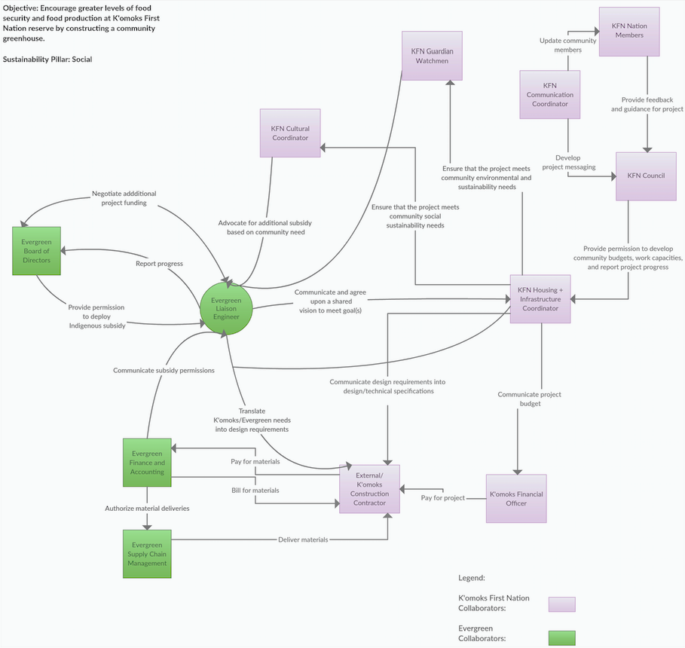
Example of a Collaborator System Map

Fig. 1: Collaborator System Map. A high-resolution landscape version of this systems map can be found on Canvas.

- Identifies an appropriate first point of contact at K’omoks Nation and includes a draft email proposing an introductory conversation. Emails can be found on the K’omoks First Nation Website. A stellar email will respectfully and concisely call the proposed point of contact to action. This email, its proposed contact and the subject line are to be included in the pdf document after the objective maps.

Important note: This draft email will NOT be sent to the contact. The draft will be submitted as text within the deliverable pdf. The purpose of this email draft is to think critically about how to respectfully begin a dialogue and express interest in working together toward a common goal with a community.

- Outlines and justifies in 2-3 sentences the step in the design process where Evergreen should contact K’omoks to begin collaboration.

In APSC 100, you were introduced to the engineering design process. This is the “recipe” for engineering work, and guides the design of shared collaboration objectives. Please answer question 4 using the steps in this design framework.

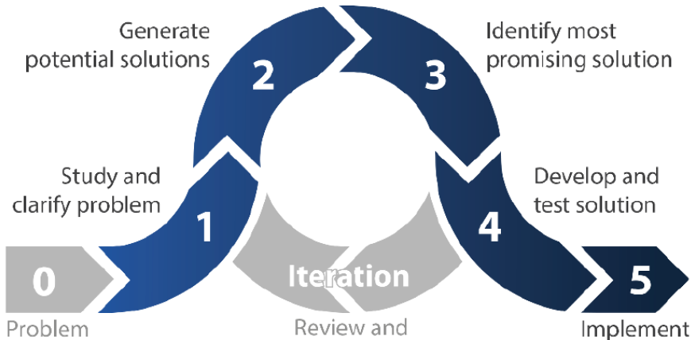
Fig. 2: Design process, UBC APSC 101

Guiding questions for success
- Can you clearly articulate the value proposition to management at Evergreen and different stakeholders K’omoks Nation?
- Are you considering the full diversity of stakeholders internal and external to K’omoks and Evergreen?

Supplementary Resources
- ʔaq̓am - ka kniⱡwi·tiyaⱡa (Our thinking): This is the Community Strategic Plan of ʔaq̓am Nation. You can compare the objectives of K’omoks Nation to those outlined by ʔaq̓am
Nation to get a sense of common goals and variation in community values across First Nations

