Synthesizing Ways of Knowing - Polarity Case Study
Pre-Assignment Reading
Please read the following CBC article, court case summary and the timeline of events below:
- CBC Article: 'We still have title': How a landmark B.C. court case set the stage for Wet'suwet'en protests
- Court Case Summary: Delgamuukw Case

Learning Outcomes
After the completion of the assignment and accompanying lecture, you will be able to:
Knowledge | Skills | Attitudes
-Define “way of knowing”  -Appraise the strengths and limitations of the empirical way of knowing  -Synthesize two cross-cultural perspectives to create a shared strategy with polarity mapping  -Differentiate normative claims from prescriptive claims | -Construct a polarity map based on a general recipe  -Demonstrate cross-cultural analysis by compiling the guiding principles of two ways of knowing | -Express interest in uncovering personal and group biases  -Reconcile apparent problems and dichotomies - one or the other solutions, as polarities - valid solutions to synthesize

Condensed Timeline

2012 — TC Energy is selected by LNG Canada to design, build, own and operate Coastal GasLink. TC Energy begins a community engagement process, followed by environmental and engineering studies along the proposed route.

2014 — Coastal GasLink files the Environmental Assessment Application with the BC Environmental Assessment Office and a detailed project design application to the BC Oil and Gas Commission. The project’s conditional Environmental Assessment Certificate was awarded October 24, 2014.

November 2014, the Wet’suwet’en First Nation Band, Chief and Council and the Province of British Columbia, represented by the Minister of Aboriginal Relations and Reconciliation signed the “Natural Gas Pipeline Benefits Agreement”, outlining a project payment of 2.32 million dollars in exchange for use of land encompassed in Wet’suwet’en territory along with other benefits.

2019 — The Wet’suwet’en Nation comprises 5 clans, each clan split into house groups who take care of different territories. The Unist’ot’en House of the Gilseyhu Clan are responsible for protecting a territory known as Talbits Kwa, through which the Coastal Gaslink pipeline is proposed to be constructed. The main access to this territory is the Morice River Bridge. Many of the Wet’suwet’en hereditary chiefs oppose the pipeline plans, and the Unist'ot'en house have committed themselves to safeguarding with the construction of checkpoints along the road to Unist'ot'en. These checkpoints were used to prevent Coastal Gaslink from beginning pipeline construction in the territory.

January 7th 2019, the Supreme Court of British Columbia issued an injunction, (a judicial order compelling a party to do or refrain from certain acts) prohibiting the prevention of freedom of movement over the Morice River Bridge. This injunction application was made on behalf of the plaintiff, Coastal Gaslink Pipeline LTD to those delaying access to the bridge and preventing the construction of the Coastal Gaslink Pipeline. This order also included enforcement injunctions so that the Royal Canadian Mounted Police (RCMP) and other appropriate police authorities could forcibly arrest and remove any person contravening the order, and detain them until they appear before court.

In the following weeks, the Unist'ot'en camp which occupied the Morice River Bridge was dispersed. The RCMP detained and arrested 14 protesters on site, enabling Coastal Gaslink passage across the bridge.This sparked indigenous rights and environmental solidarity protests in 70 cities around the world, according to the Unist’ot’en.

2020 — May 14 2020, a Memorandum of Understanding between the Ministers of Indigenous Relations and the 9 active Wet'suwet'en Hereditary Chiefs that recognize Indigenous rights and title through hereditary governance and commit to negotiations over the following 12 months.

Assignment Deliverable - One pdf document which:
- Answers the following questions:
  - What are differences in the ways of knowing sovereignty between Coastal Gaslink Pipeline LTD and the Wet’suwet’en hereditary chiefs? Hint: This question relates to interpretation of legal authority. Please answer this by providing two prescriptive statements, one from the perspective of each party.

Example of a prescriptive statement: Engineering students should keep up with current events.

  - What are the assumptions that justify these two prescriptive statements?

Example assumption: Current events allow engineering students to see how their classes apply to the world.

  - Can proof of the two statements be observed? If so, where? If not, why not?

- Contains a polarity map that clarifies a shared challenge that has not yet been achieved by Coastal Gaslink Pipeline LTD and the Wet’suwet’en Hereditary Chiefs. Imagine that this map could be co-created at the negotiation table by both parties. The instructions for creating a polarity map are below:
  - Define the Challenge
  - Identify Key Polarities
  - Label Poles
  - Brainstorm Content
  - Identify the Action Steps
  - Identify Early Warnings

You are encouraged to create your systems map layout to suit your space needs, however the template below may also be used.

- Outlines and justifies in 2-3 sentences the step in the design process where Coastal Gaslink and the Wet’suwet’en should reintroduce consultation measures moving forward.

In APSC 100, you were introduced to the engineering design process. This is the “recipe” for engineering work, and guides the design of shared collaboration objectives. Please answer question 3 using the steps in this design framework.

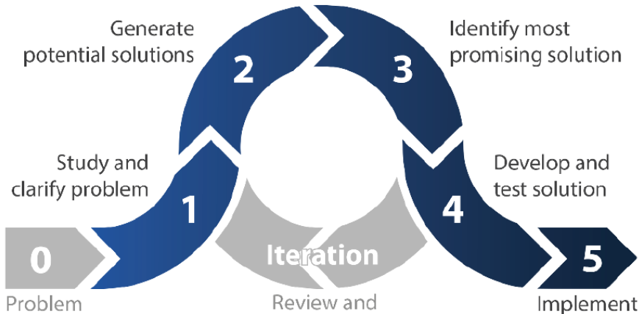
Fig. 2: Design Process, UBC APSC 101

Example Polarity Map
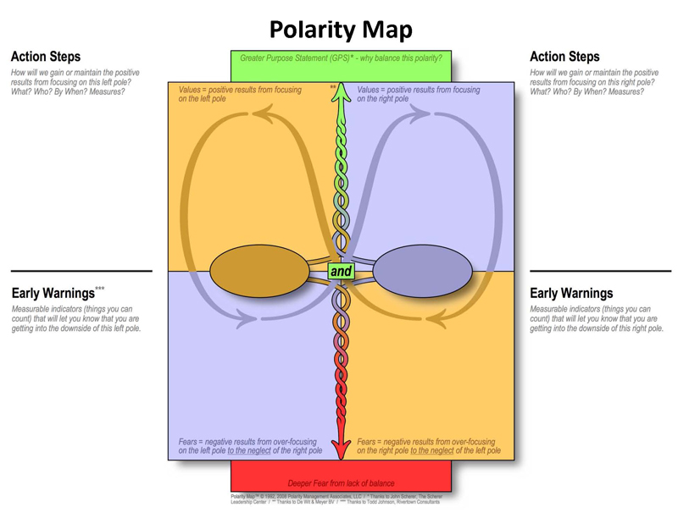
Fig. 2: Empty polarity map template. Polarity Map, Barry Johnson and Polarity Partnerships, LLC, All rights reserved.

Supplementary Articles
CBC News: Why Coastal GasLink says it rejected a pipeline route endorsed by Wet'suwet'en hereditary chiefs
CBC News (Opinion): There are two kinds of Indigenous governance structures, but Canada has been listening to just one
The Globe and Mail (Opinion): The Coastal GasLink dispute highlights the complicated, essential need to balance rights

