Synthesizing Ways of Knowing
What is a way of knowing? Students, teachers and engineers are being asked to consider Indigenous “ways of knowing”, which may sound foreign from the way in which engineers apply knowledge. What is being asked of engineers when considering Indigenous ways of knowing? What should be done about conflicting worldviews in engineering projects? I hope to answer these questions in the following lesson outline.

Learning Outcomes

Knowledge | Skills | Attitudes
-Define “way of knowing”  -Appraise the strengths and limitations of the empirical way of knowing  -Synthesize two cross-cultural perspectives to create a shared strategy with polarity mapping  -Differentiate normative claims from prescriptive claims | -Construct a polarity map based on a general recipe  -Demonstrate cross-cultural analysis by compiling the guiding principles of two ways of knowing | -Express interest in uncovering personal and group biases  -Reconcile and reframe apparent unresolvable, opposing problems by using a polarity map

Way of Knowing Defined
To begin, let’s define what is meant by a “way of knowing”. A way of knowing is a tool used to acquire knowledge. These tools include:
- Language.
- Sense Perception.
- Emotion.
- Reason.
- Imagination.
- Intuition.
- Memory.
- Faith.

There is no “perfect” method to acquire knowledge. Some people prioritize a way of knowing that is useful to society, to themselves, or to some other goal.

The Difference Between What we Know & Ways of Knowing
To clarify the difference between what we know and ways of knowing: what we know is what we have taken to be true. For example, “the grass is green”, or “I love my cat” are things that I know. How I came about that knowledge is a way of knowing. So I know the grass is green based on observation. I know that I love my cat based on the emotions I feel when I interact with him.

The Empirical Way of Knowing
Overview
One such way of knowing is near and dear to scientists and engineers worldwide is empiricism. The empirical method supposes that the way that we gain knowledge is primarily by sensory experience. Although this may seem to be self-evident to those who have been scientifically trained, this is a relatively new feature of human thinking that was only explicitly formulated three centuries ago by John Locke. The empirical method is especially useful for creating and distributing knowledge systems (e.g. sciences) that delineate the specific properties of the natural world.

In 2015, the Laser Interferometer Gravitational-Wave Observatory (LIGO) detected a cataclysmic cosmic event; two black holes with 30 times the mass of the sun had collided in the distant universe. This collision caused detectable ripples in spacetime, which were independently observed at the LIGO observatories in Livingston, Louisiana and Hanford, Washington in the United states. This observation aligned with a theory postulated 100 years ago by Einstein that gravitational waves exist. The empirical evidence is strong: the “fingerprints” that are left behind by the collision were measured in Livingston and Hanford, and they are nearly identical when superimposed. Astrophysicists can now confidently declare that gravitational waves exist, thanks to empiricism and the scientific way of knowing, or method. Framing the truth to be what is observable is a powerful tool for understanding the physical world.

Limitations of the Empirical Way of Knowing
However, what is science unable to do? Science does not provide a framework for making statements of value. For example, Scottish historian and philosopher David Hume noted the difference between descriptive and prescriptive statements. Descriptive statements can be directly observed, whereas prescriptive statements describe what will happen. Assumptions must be made when you justify a prescriptive statement with a descriptive statement.

Take for example the declaration: “Our human ancestors ate the meat of domesticated and wild animals, so vegetarians should really be eating meat”. Here, we have two statements. One descriptive statement about the nature of the human diets, historically speaking, and one prescriptive statement related to what vegetarians should be doing instead of avoiding meat. The prescriptive statement presumes that what is “natural” is more important than the vegetarian’s choice to abstain from meat. This prescriptive statement on value pertains to ethics and cannot be inferred by scientific observation. A leap must be made to connect the descriptive and prescriptive statements. Here are some other questions whose answers cannot be derived from the scientific way of knowing alone:

Moral judgements | Aesthetic judgements | Uses of scientific knowledge
Should we send people to prison?  Should education be mandatory? | Is country music better than hip hop?  Is it preferable to live in the beauty of the country or the liveliness of the city? | Should we use genome editing to cure disease?  Is Artificial Intelligence safe enough to be commonly used in self-driving cars?

Questions like these that partially or fully outside of the realm of science have far-reaching implications in the ways we structure societies. Engineers are entrusted to make decisions on behalf of populations with highly variable values and belief systems. If engineers are to suit the project to the user or group of users, we must understand what other ways the users have come to understand existence. Our designs better serve people when we accept different ways of knowing as being valid.

Ways of Knowing, Equity, and Synthesis

Engineering culture values reason, progress and rationality. The fast-paced technological environment that we work in requires a keen understanding of the empirical. Ideas and ways of knowing that don’t align with traditional methods of acquiring knowledge in engineering are often “ignored”. To treat different ways of knowing equitably, we need to consider different sources of the truth and of value as both real and consequential.

Consider the way we view time. Some people visualize time as a linear concept. Others view time as a cycle. One way to synthesize these concepts visually would be to depict time as a cyclical roller coaster:

Let’s look at another example. Consider a rock: is a rock alive?

According to Empirical knowledge, a living thing:
- Eats
- Breaths
- Reproduces
- Grows
- Poops
- Responds to the environment (sweats in the heat, shivers in the cold, etc)

Based on observation, a rock doesn’t do any of these things, so according to the empirical way of knowing, a rock is not alive! Let’s say there is a body of knowledge, though, that says everything on Earth is alive, including rocks, water, and wind. According to this body of knowledge, the rock is alive.

So, is the rock really alive? Well, in the empirical definition, no! But the other way of knowing cannot be disregarded or disrespected. So according to that way of knowing, the rock is alive! To consider different ways of knowing equitably, you must acknowledge that spiritual or emotional justification, not just the empirical, is valid & valuable.

To design equitably, we must synthesize the ways of knowing of all collaborators participating in a design project. Let's consider an example of this. Say you work for a sportswear manufacturing company, which specialized in items such as hockey and lacrosse sticks. Your manager has recently asked you to liaise with a prominent Canucks player to try and sell a custom hockey stick to him.
You have a background in materials engineering. Therefore, you are well versed in what range of elastic modulus, toughness, and strength is required of the materials you use when manufacturing the hockey sticks. You understand that the density of the material is important, and you tend to stick to density standards set out by your company. You know that you can absolutely sell a good stick to your client as long as the client can describe the technical specifications of his favorite stick(s). You set up a meeting with your client and are shocked when he describes what he needs.
Client: It can't be too heavy since I focus on quick stick work. it needs to have some "give" but stiff for pokes. I need an extension of my body, not deadweight. It's got to be balanced, it can't have a bunch of extra weight in weird spots, otherwise I can’t get a fast shot off. The blade needs to be curved but not too much. It also needs to have some flex for the slap shots.
Is your way of knowing what goes into the perfect hockey stick flawed? Is your client’s? No! You both use observation and testing to determine the best hockey stick - you just need a way to translate between the ways of knowing to benefit both you and your client.

Respectfully Synthesizing Ways of Knowing
What happens if two ways of knowing conflict with each other, or if it appears that there is no way to synthesize the two ways of knowing? In the engineering design process, who gets to decide the necessary assumptions on what is valuable and what is not? The answer is that those who will be affected will decide.

Problems vs Polarities
Equipped with the empirical scientific methods, engineers are famously skilled problem solvers. One popular problem solving strategy is to simplify complex systems into smaller, more manageable problems. Although useful, it is not always the best strategy. As previously established, there is no objective right answer to questions pertaining to values, unless assumptions are made. In these more complex cases, multiple equally plausible points of view need to be synthesized into a strategy. Discussions can become especially contentious when the participants in strategy development bring forward diverse ways of knowing. A great tool to reach for during these seemingly clashing is the polarity map

When to Use a Polarity Map
The development of a polarity map allows a group of people to become more aware of the advantages and drawbacks to a pair of strategies that may seem at odds. This process can be applied to synthesize ways of knowing, since all ways of knowing have different domains of utility. Some great indicators that a polarity based mindset is useful to apply are:

- There is no way to know that one proposed point of view or strategy is better than the other.
- The dilemmas produced by differing priorities and strategies are ongoing, and seemingly unresolvable.
- Success hinges upon collaboration and mutual understanding of all parties involved.

How to create a Polarity Map
Once you have identified that a polarity map is useful, build a map together with this recipe. Examples could include:
- Any project: Client needs vs contractor needs
- Site C dam: BC hydro vs local indigenous peoples
- Choosing stability or change

- Define the Challenge: Identify a task that both parties have the ability to change which has not yet been achieved. This challenge is the worthwhile goal of synthesizing seemingly opposing strategies.

- Identify Key Polarities: Select the x axis of the plot, with each end of the axis representing alternative strategies or priorities. These are to be written as complete sentences..

- Label Poles: Include unbiased labels for both poles

- Brainstorm Content: Identifying the positive and negative aspects of each pole. One method is to have team members write this content on sticky notes and subsequently place them on the map together while justifying their inclusion in the matrix.

- Identify the Action Steps: These action steps are what can be done as a whole to reap the benefits of each pole.

- Identify Early Warnings: These warnings will act as caution flags when the strategy to achieve the challenge is incurring the drawbacks of each pole.

Empty Polarity Map
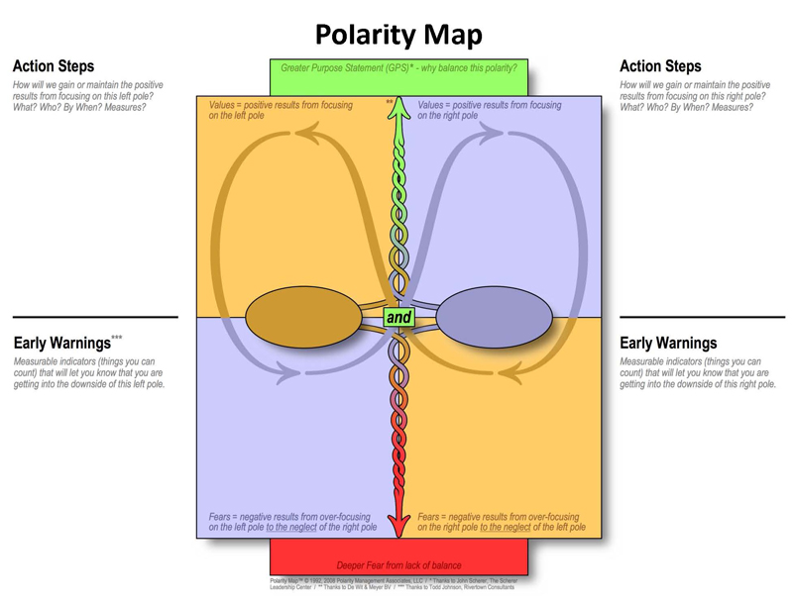
Figure 1: Empty Polarity Map Template, Polarity Map, Barry Johnson and Polarity Partnerships, LLC, All rights reserved.

Example of a Completed Polarity Map
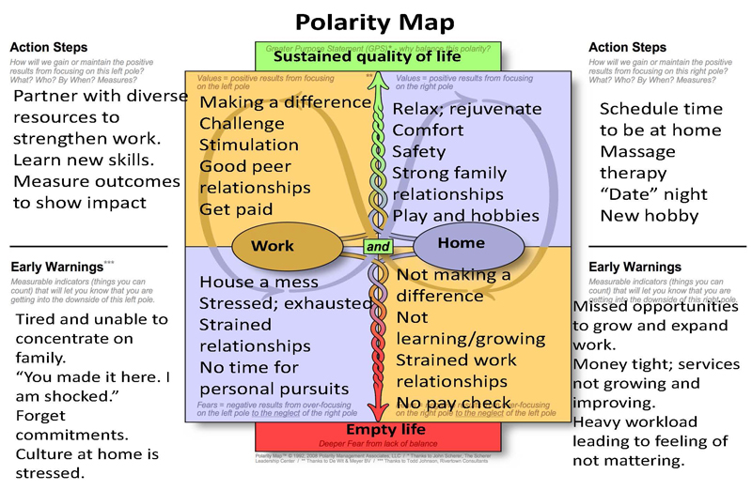
Figure 2: Completed Polarity Map Template, Polarity Map, Barry Johnson and Polarity Partnerships, LLC, All rights reserved.

Lesson Summary
This lesson:
- Introduced ways of knowing as a framework for interpreting reality
- Defined the empirical method and outlined its utilities and limitations
- Differentiated normative from prescriptive statements
- Introduced equity in ways of knowing as a tool for decolonization of engineering
- Outlined the process for creating a polarity map

This information is key to understanding how Western Scientific authority is used to “other” Indigenous and other perspectives, and provides a method to synthesize ways of knowing instead of resorting to exclusionary practices.

Sources
IB Theory of Knowledge. (2020, May 22). Retrieved from Wikibooks: https://en.wikibooks.org/wiki/IB_Theory_of_Knowledge

Resource: Polarity Mapping. (2017, May 27). Retrieved from University Innovation Fellows: https://universityinnovation.org/wiki/Resource:Polarity_Mapping

Truncellito, D. A. (n.d.). Epistemology. Retrieved from Internet Encyclopedia of Philosophy (IEP): https://www.iep.utm.edu/epistemo/

Dei, G. (2008). Indigenous Knowledge Studies and the Next Generation: Pedagogical Possibilities for Anti-Colonial Education. The Australian Journal of Indigenous Education, 37(S1), 5-13. doi:10.1375/S1326011100000326 https://www.cambridge.org/core/journals/australian-journal-of-indigenous-education/article/indigenous-knowledge-studies-and-the-next-generation-pedagogical-possibilites-for-anticolonial-education/6230A2538AA0E82074BA7D71560CF0E4

