**LAB 3: RELATIVE GEOLOGIC TIME AND STRATIGRAPHIC INTERPRETATIONS**

**PART I: RELATIVE TIME AND STRATIGRAPHY INTRODUCTION**

**EXERCISE 3.1. Identifying Unconformities**

In Figure 3.2, an unconformity surface has been marked with a dark wiggly line. The specific type of unconformity is different depending on where along the wiggly line you look. Find examples of the three types of unconformities in Figure 3.2 and draw them in the labeled boxes. Include the rock textures (patterns) as they appear in the geological cross-section.



**Figure 3.2:** Geological cross-section.

**EXERCISE 3.2. Reconstructing Relative Geological Time**

Figure 3.3 is a geologic cross-section where each rock unit is assigned a letter as a label. Use the labels in Figure 3.3 and the stratigraphic principles to answer the questions that follow.

All rocks are sedimentary except for the following:

* **H**: metamorphic
* **P** and **S**: intrusive igneous rocks

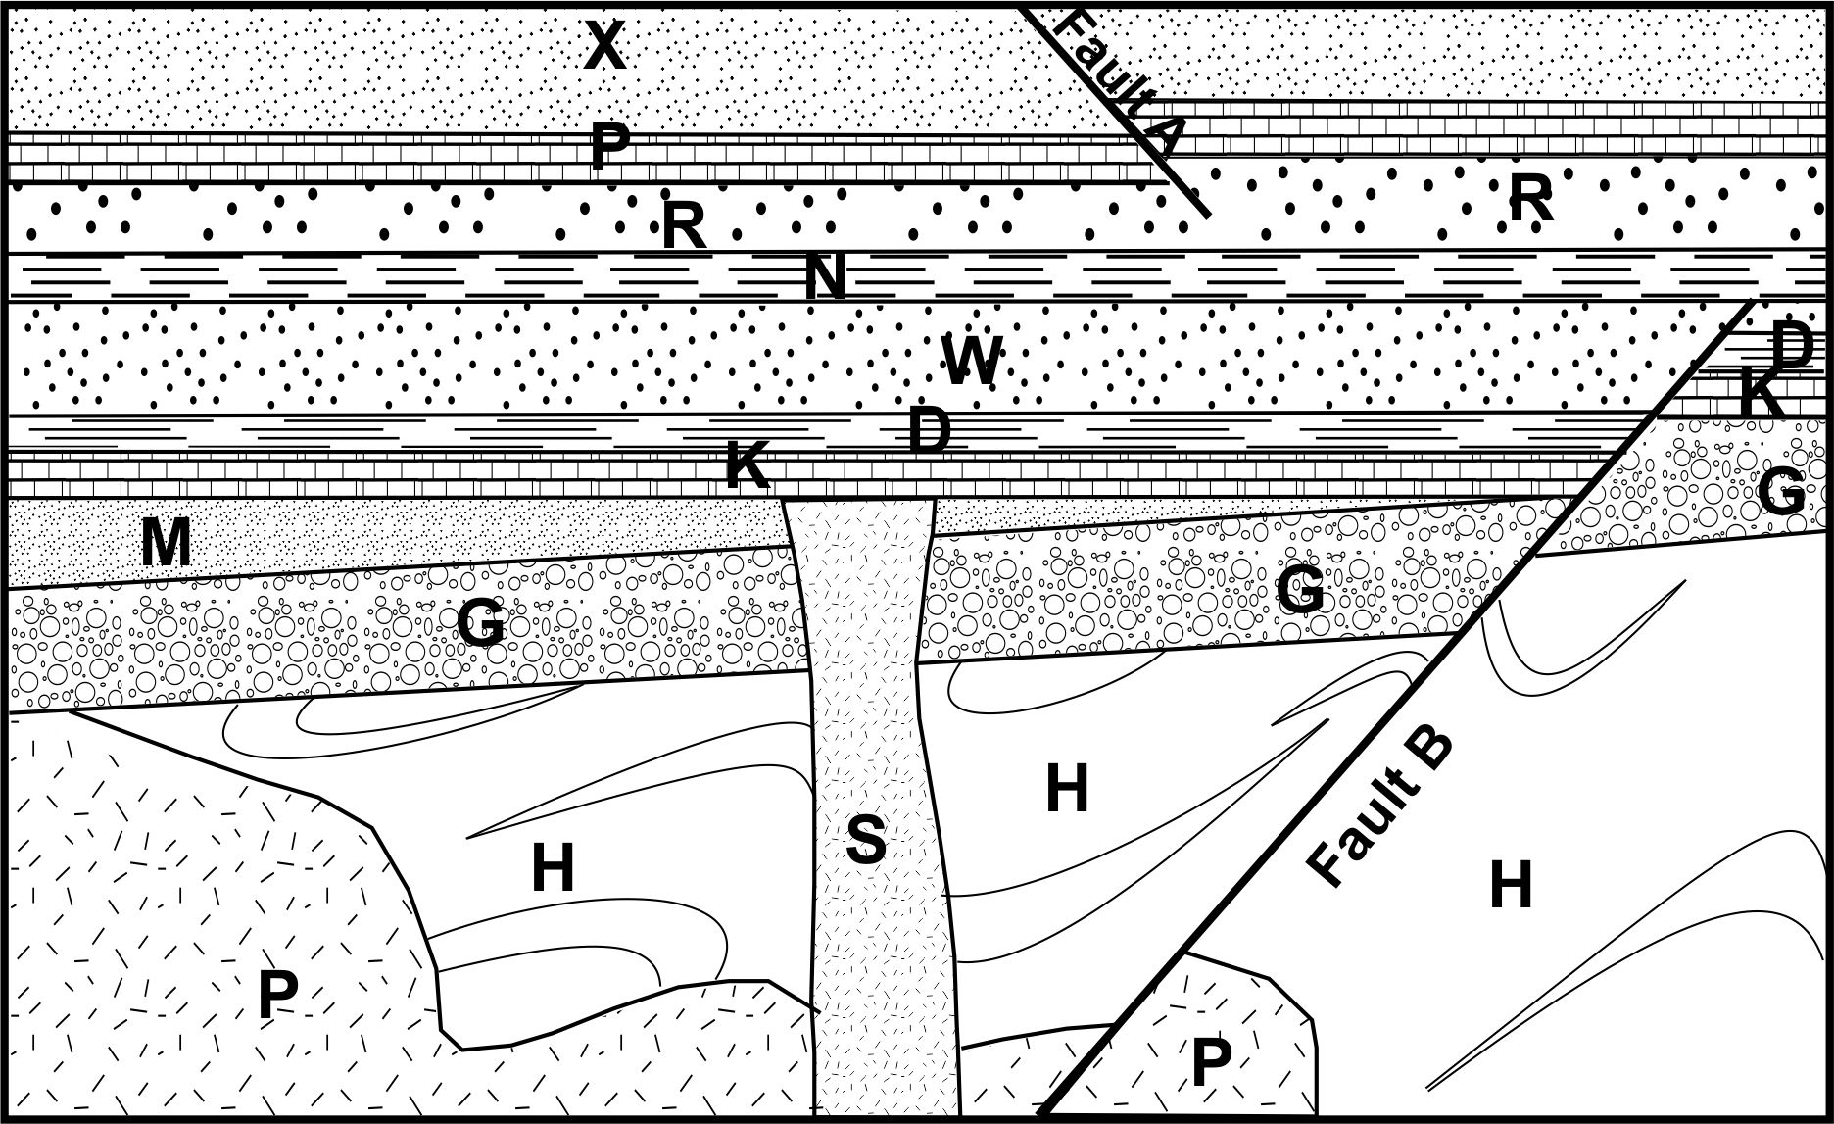

**Figure 3.3:** Geological cross-section.

The space below is provided for you to make notes.

1. Which is the oldest geologic event? ____________________________________________________
2. Which geologic events are definitely older than the intrusion **S**? ____________________________
3. What stratigraphic principle is used to date **Fault B** on the right side of the figure?

_________________________________________________________________________________

1. Which pairs of rock layers define unconformities? ________________________________________

To help you with question 6, it may be useful to mark the location of each of these on your drawing by making these contacts thicker, or by using a coloured pencil to highlight their locations.

1. Which is the most recent (youngest) geological event in the cross section above?

________________________________________________________________________________

1. Place the rock units and the faults (using the letters A and B) in order ranging from the oldest to the youngest by placing the corresponding letters into the spaces below.

(Oldest) ____, ____, ____, ____, ____, ____, ____, ____, ____, ____, ____, ____, _____, _____ (Youngest)

**PART II: INTERPRETING STRATIGRAPHY IN A STRATIGRAPHIC LOG**

**EXERCISE 3.3 – Interpreting Stratigraphic Logs**

Tables 3.2 and 3.3 summarize stratigraphic logs from two different locations. Use the following instructions to interpret and complete each log. *Note: The online Lab Manual includes an example of what a completed log might look like.*

1. Identify the depositional environment by interpreting the written facies description and drawn stratigraphic column using the information from Lab 2. Write the name of the environment next to the log sketch.
2. Starting at the bottom of the log, decide whether the transition from one facies to the facies above it represents a change to a deeper water facies (transgression) or a shallower water facies (regression). Write the corresponding change (T or R) in the box on the horizontal line separating the two facies.
3. In the right-hand column, plot the facies according its location by shading the correct dot. For example, if an environment is a beach, shade the dot under "Beach." There are also dots for intermediate environments. If an environment has deeper water than "Beach," but shallower than "Shelf," you would shade the dot between those two environments. Remember that the progression from fine far-offshore sediments to coarse coastal sediments may not be smooth. Once you've shaded the correct dots, connect the dots using straight lines to create a sea level curve like the one shown in Figure 3.9.
4. Indicate periods of transgression or regression by placing arrows on the straight lines pointing left (transgression) or right (regression). (See Figure 3.10 in the online Lab Manual.)

**Table 3.2:** Siliclastic dominated system.

|  |  |  |  |
| --- | --- | --- | --- |
| **Facies Description** | **Strat.**  **Log** | **Environment** | **Relative Sea Level**  **Trans. or**  **Regress.**  **T/R\***  **High Low**  **(Transgressions) (Regressions)** |
| **Ocean Terrestrial**  **Basin Shelf Beach Distal Proximal** |
| Hummocky sequences; silt; low angle cross beds and ripples; abundant marine fossils |  | |            *Shade the correct dot for each environment, then connect the shaded dots to draw the sea-level curve.*                                                |
| Gravels downcutting laminated silts, overlain by sands, then silts, plant fragments |
| Dark organic silt, mud, storm wash sand layers, Cruziana |
| Quartz sst.; abundant ripples, Skolithos |
| Hummocky sequences; sand and silt with a layer of gravel near the base |
| Qtz sst.; gently dipping parallel laminations, shells, wood debris. |  | |           |

* Starting from the bottom of the stratigraphic column, mark in the box next to each boundary line between facies whether the facies change, moving upwards in the column, represents that sea level is transgressing (T) or regressing (R).

**Table 3.3:** Carbonate dominated system.

|  |  |  |  |
| --- | --- | --- | --- |
| **Facies Description** | **Strat.**  **Log** | **Environment** | **Relative Sea Level**  **Trans. or Regress.**  **T/R\***  **High Low**  **Transgressions Regressions** |
| **Ocean Terrestrial**  **Basin Shelf Beach Distal Proximal** |
| Light-grey, unbedded biolithite; debris flows and slumps | Lab 3 Carbonate Column.tif | | *Shade the correct dot for each environment, then connect the shaded dots to draw the sea-level curve.*                                                                 |
| Medium-bedded micrite with lime sand lenses; clam coquina, patch reefs |
| Algal laminated dolomite; mud cracks., gypsum |
| Grey-green hummocky beds of packed biomicrite interbeddd with very burrowed biomicrite |
| Thinly laminated black micrites |

* Starting from the bottom of the stratigraphic column, mark in the box next to each boundary line between facies whether the facies change, moving upwards in the column, represents that sea level is transgressing (T) or regressing (R).