LAB 4: STRATIGRAPHIC CORRELATION

Exercise 4.1. Beginner Correlation Exercise
- Draw lithostratigraphic correlation lines between the rock units A, B, and C in Figure 4.7. Use solid lines for correlations you are confident about and dashed lines for ones that are tentative.
- Draw lines to correlate any unconformities and label them with their type.
- Answer the questions on the next page.

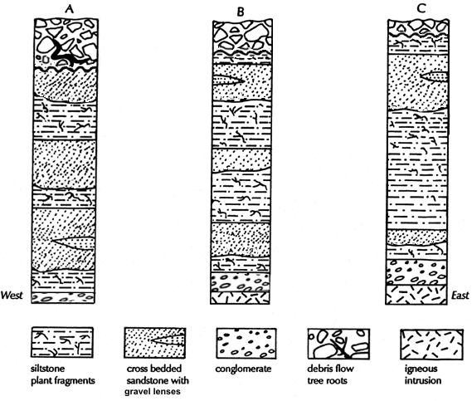

Figure 4.9: Stratigraphic columns for Exercise 4.1.

- Were units A, B and C deposited in terrestrial or marine environments?

- Locate the unconformity at the bottom of units B and C and draw a dark wiggly line at its location. Name the type of unconformity at the bottom of units B and C.

- What happens to the conglomerate from east to west?

- In which direction was the source of sediments for the conglomerate?

- What happens to the middle sandstone unit between B and C?

- What depositional environment created the middle sandstone and siltstone sequence?

- What type of regional scale unconformity could occur below the debris flow deposit?

- The debris flow deposit could also be just a local process where a coarse-grained alluvial fan advanced over the sedimentary environment you identified in (g). What other information would you need to decide which of these two options (regional erosion, local erosion) is correct?

Exercise 4.2. Intermediate Correlation Exercise

- Draw lithologic correlation lines to connect equivalent rock units (shown using Roman numerals) in Figure 4.10.
- The numbers beside the rock units correspond to time intervals. Using a different colour, draw lines connecting equivalent time-stratigraphic units.
- Answer the questions on the following page.
Figure 4.10: Stratigraphic columns for Exercise 4.2.

- Identify the depositional environment of the following facies descriptions. Transcribe these environments onto Figure 4.9.

- The bedrock is granite gneiss. (No depositional environment.)

- Mature white quartz sandstone with crossbeds and Skolithos trace fossils.

- Tan coloured shale and siltstone, some hummocky beds and Cruziana traces.

- Light grey biomicrite with thinly laminated and hummocky beds.

- Black, thinly laminated shale with Zoophycus traces.

- Dark grey shale and sandstone showing graded beds, and sole marks in cyclic bedding.

- Greenish siltstones at base becoming tan medium sans with metre-scale crossbeds, rare shells.

- Reddish brown, clast supported conglomerate interbedded with Crossbedded brown, immature coarse sandstone and mud-cracked siltstone.

- What is happening to relative sea level between time intervals 1 and 4?

- In which direction was the source for the sediment that forms unit (ii)?

- Where would the deepest part of the sedimentary basin have been at time 1? Where would the shoreline have been?

- Where is the deepest part of the basin (the lowest elevation) at time 4?

- What was happening to relative sea level between time intervals 4 and 8?

- Where was the shoreline at time 7? How did you come to this conclusion?

- What does the appearance of (viii) directly on top of (vii) tell you about the sedimentary history of this region?

- Could this whole sedimentary sequence be created by global sea level rise and fall only? What other processes could have occurred?

Exercise 4.3. Advanced Correlation Exercise

- Draw lithologic correlation lines to connect equivalent rock units in Figure 4.11.
- The numbers beside the rock units correspond to time intervals. Using a different colour, draw lines connecting equivalent time-stratigraphic units.
- Answer the questions on the following page.
Figure 4.11: Stratigraphic columns for Exercise 4.3.

- Not all the conglomerates are the same age. How could this occur?

- In what direction is the sourceland for the lower sandstone layer?

- What happens to the thickness of the shale layer from east to west? Considering your answer from (b) above, how do you explain this?

- Why is stratigraphic log A thinner than log G even though it represents a longer stratigraphic time interval?

- In log A, between which two time periods was the rate of sedimentation the greatest?

- In which log (A-H) was the rate of sedimentation the greatest?

- What is happening to water depth from time interval 1 to 6?

- What geologic processes or events do you think may have created the sedimentary patterns seen in this cross section?

