FortiGate Firewall: Practical Guidance and Hands-On Labs Style Sheet
Last revised: 06/01/2022
House Style: BCcampus Open Education Publishing Style Guide
Author(s): Hamid Talebi

Book Structure

Headings
- Headings in each chapter always start with heading 1
- Subheadings are heading 2, then heading 3, etc

Images
- Generally, images are inserted full size and centered.
- Generally, all images will have figure numbers in the caption field

Text style
- New terms: Bold
- Navigation: Bold.
- Action of Users: Bold
- commands: Italic- Inside shaded box
- scenarios: Inside shaded box

Textboxes
- Commands: Inside shaded textbox- Italic
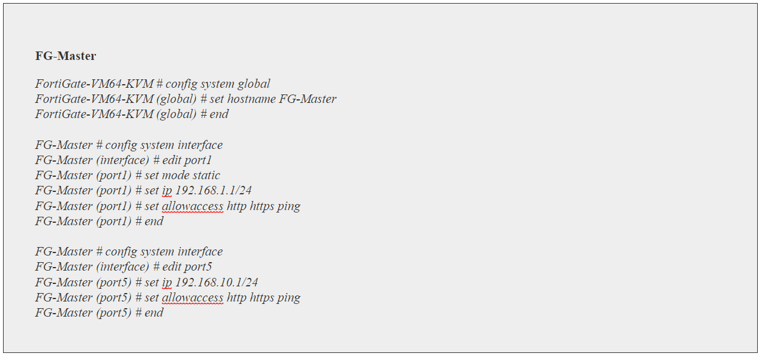
- Scenarios: Inside shaded textbox
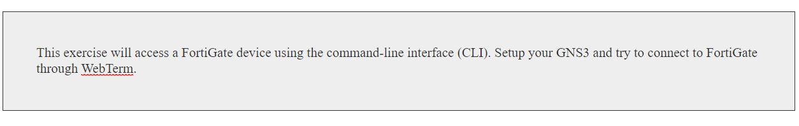
- Learning Objectives:
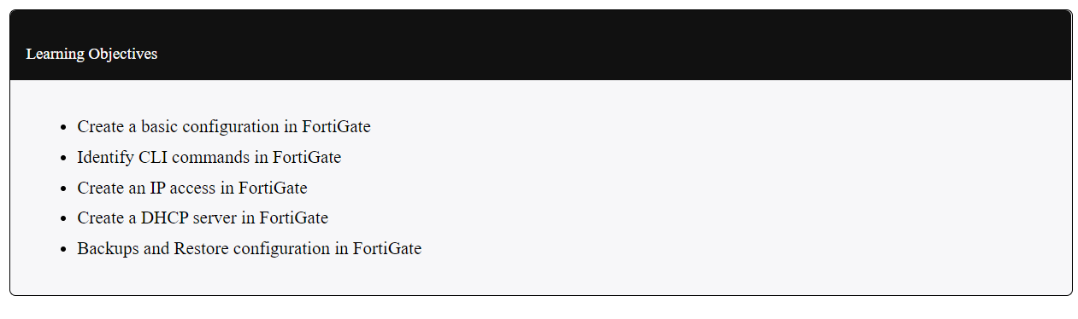

- Notes: Standard textbox

