Student Workbook for:
Lab 02: Earth-Sun Relationships & Earth’s Energy Budget
By Andrew Perkins

Exercise 1: Earth-Sun Relationships and Earth’s Energy Budget

Question 4. a.

Table 2.1. Actual amount of radiation received at Earth's surface on the equinoxes and solstices at three locations.
Month | Equator | Tropic of Cancer | North Pole
March
June
September
December

Exercise 1: Earth-Sun Relationships and Earth’s Energy Budget

Question 4.b.

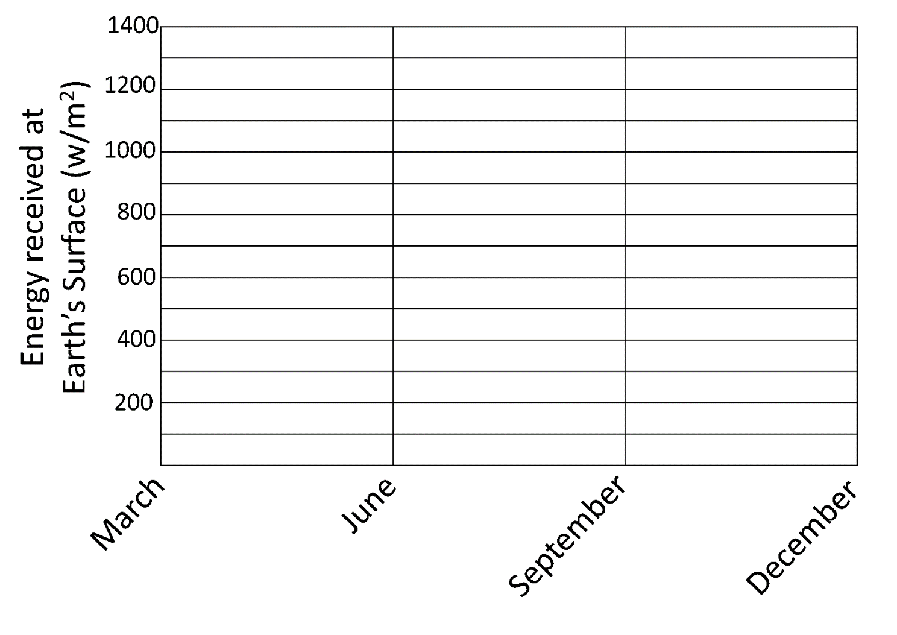 Figure 2.8. Change in energy received at Earth's surface through time. Source: A. Perkins, CC BY-NC-SA 4.0

Exercise 2: The March of the Seasons and the Angle of the Noon Sun

Question 7.

Diagram | Angle of Noon Sun | Relative Intensity of the Sun Angle
On Oct. 3rd, if you are located at 0° latitude:
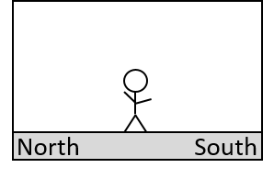

On April 2nd, if you are located at 61° North latitude:
On Dec. 9th, if you are located at 85° North latitude:

Exercise 2: The March of the Seasons and the Angle of the Noon Sun

Question 8.

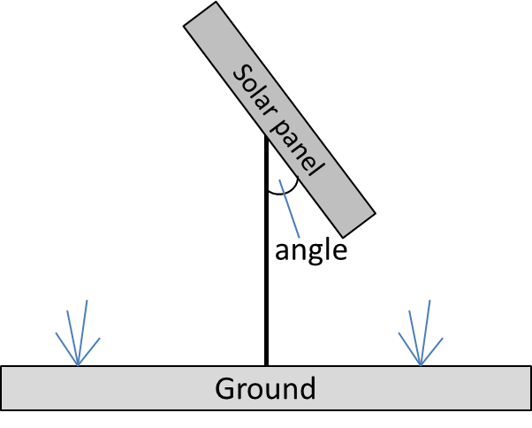 Figure 2.9. Schematic of solar panel. Source: A. Perkins, CC BY-NC-SA 4.0

Exercise 4: Lapse Rates

Exercise 4: Temperature Gradients Graph

