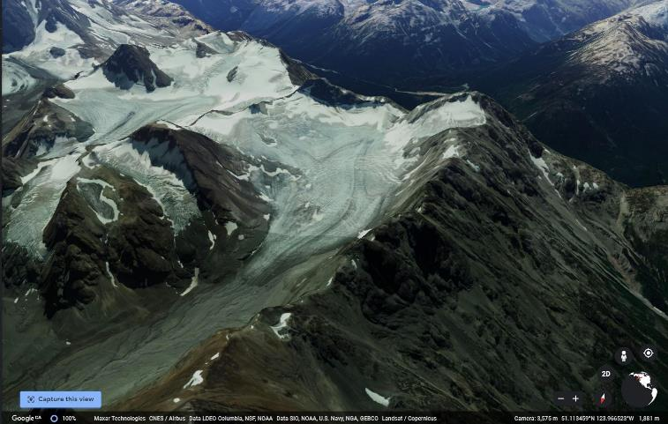
Figure 1.
The unnamed glacier (pictured above looking south) is located to the east of the southern end of Chilko Lake within Ts’ilʔos Provincial Park in the central Coast Mountains of British Columbia (51.093, -123.979). This glacier, as with many of the glaciers in this region, is an important source of late summer stream flow for Rainbow Creek, Chilko Lake, Chilko River, the Chilcotin River, and the Fraser River before it drains into the Pacific Ocean.
I chose this glacier sort of randomly. However, I’ve been curious about Chilko Lake ever since I once caught a glimpse of the lake when doing a ski traverse of the Homathko Icefield during my undergrad. Also, there was great imagery in Google Earth and the glacier ice appeared almost blue. I was also concerned to see how little snow pack was retained to balance the annual ablation.
Image Source: Google Earth accessed June 8th, 2020.
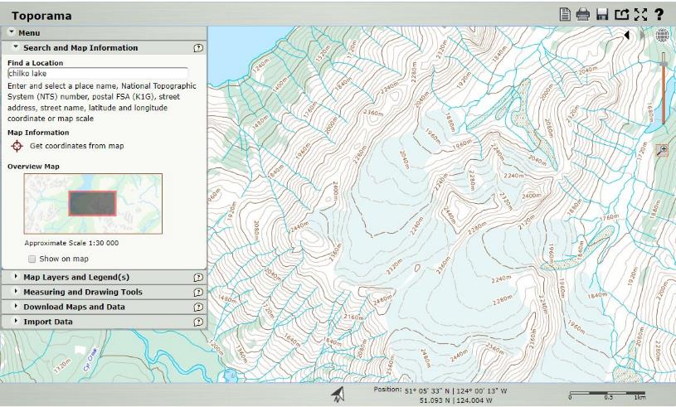
Figure 2.
This unnamed glacier lies within a north-facing cirque and extends to form a valley glacier from a maximum elevation of approximately 2440 m to 1860 m. Image Source: https://atlas.gc.ca/toporama/en/index.html accessed June 8th, 2020.
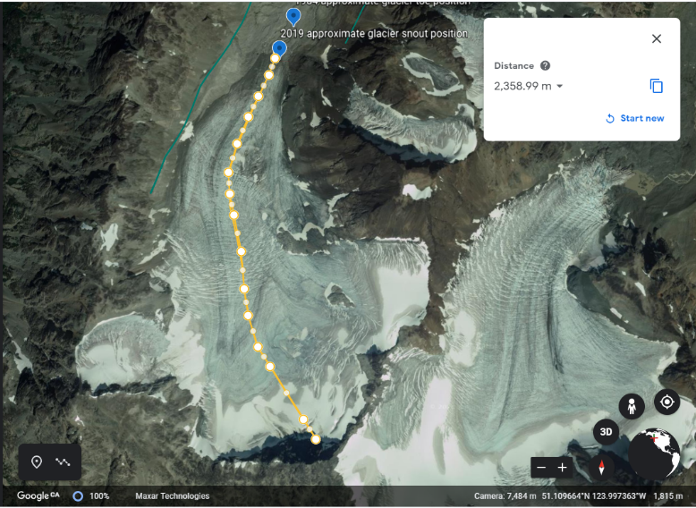
Figure 3
In this Google Earth imagery, this glacier extends 2.4 km. Image Source: Google Earth accessed June 8th, 2020.

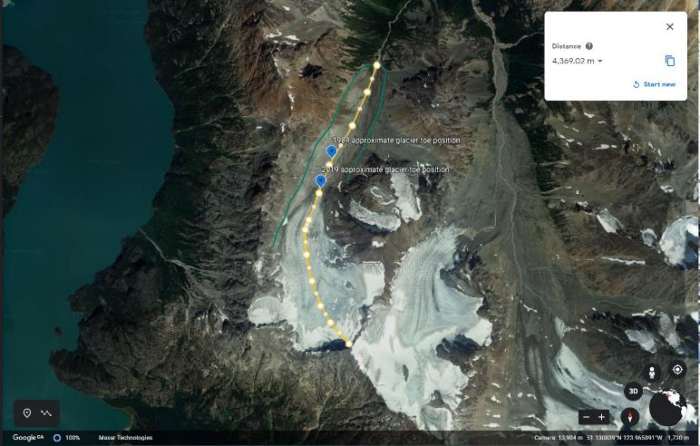
Figure 4
Several subdued moraines (outlined in green) suggest that as recently as 1850, this glacier was 4.4 km long.
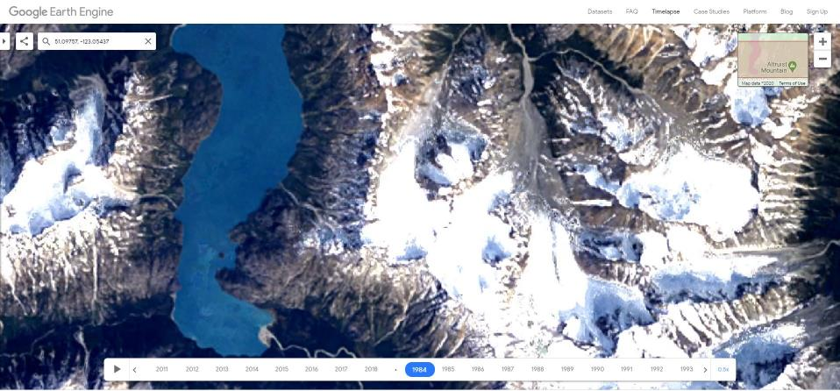
Figure 5
This image depicts the glacier in 1984. Image Source: https://earthengine.google.com/timelapse#v=51.09999,-124.00105,11.621,latLng&t=2.34&ps=50&bt=19840101&et=20181231&startDwell=0&endDwell=0
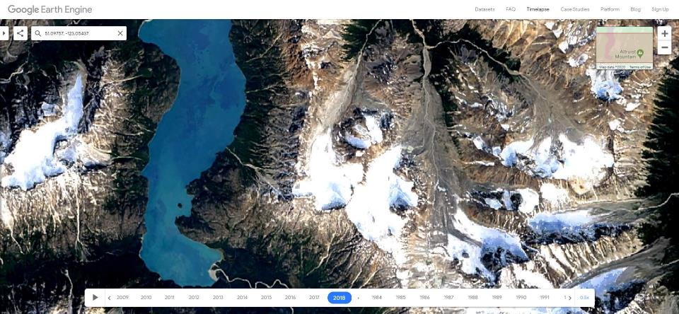
Figure 6
This image depicts the glacier 35 years later in 2018. We can see that the glacier has receded, the toe narrower, and a rock island has appeared in the upper regions of the glacier. Also, the upper area has started to divide more distinctly into three smaller cirques. Image Source: https://earthengine.google.com/timelapse#v=51.09999,-124.00105,11.621,latLng&t=2.34&ps=50&bt=19840101&et=20181231&startDwell=0&endDwell=0
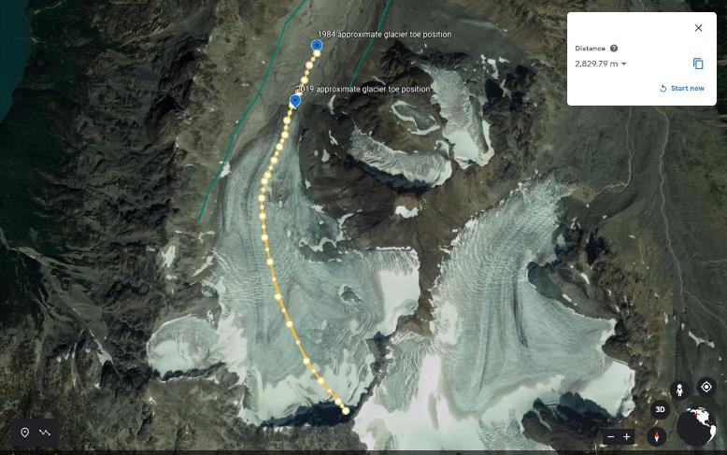
Figure 7
By locating the approximate position of the toe in 1984 Google Earth Engine Timelapse imagery, we can see that the glacier was 2.8 km long in 1984.
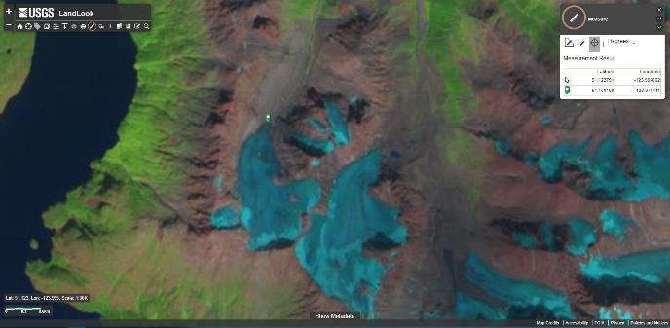
Figure 8 Looking at Sentinel 2 imagery from late August 2019, we can see why this glacier is experiencing such rapid retreat. Very little snow from the prior winter (light blue) is left to balance all of the mass of ice that was lost due to ablation (melt and sublimation) that year. Therefore, the accumulation zone is too small to prevent the glacier from retreating. Generally, for a glacier to not shrink, approximately a third (33%) of the glacier should remain in the accumulation zone and the area in the photo within the accumulation zone is far less than 33%. Other signs that this glacier is disappearing are 1) the emergence of rock outcrops (pink island in middle right-hand portion of the glacier) in the accumulation zone, 2) the snow cover is not continuous in the accumulation zone of the glacier such that the equilibrium line is no longer a continuous line. If the climate of 2019 were to represent the future (with no future warming), this unnamed glacier would retreat until it became several small disconnected glaciers or perennial snow patches. Predicted global warning will cause the glacier to disappear entirely. Image Source: https://go.usa.gov/xwNFV accessed on June 8th, 2020.
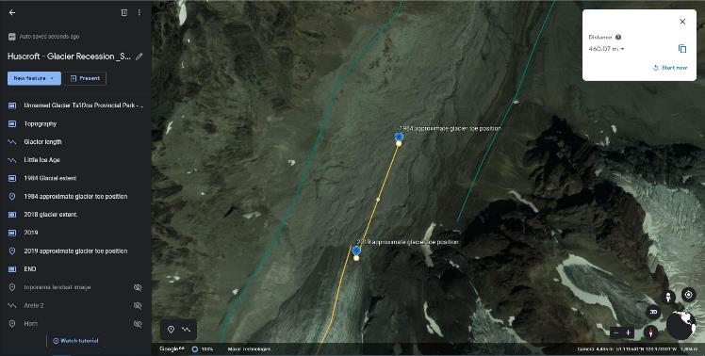
Figure 9 Between 1984 and 2019, the glacier retreated 460 meters. Therefore, it is retreating on average 13 m/yr. Image source: Google Earth Accessed June 8th, 2020.

