Applying Stakeholder Theory to Risk Communication
By Julie Zhang
This week, we learned that stakeholder engagement for communication planning, while potentially beneficial, should be employed carefully to ensure consultation is meaningful and respectful. The takeaway was straightforward: “poorly done stakeholder engagement is often worse than no stakeholder engagement at all.”¹ As such, to practice better stakeholder engagement, I believe risk communicators can benefit from applying stakeholder theory in their communication efforts.
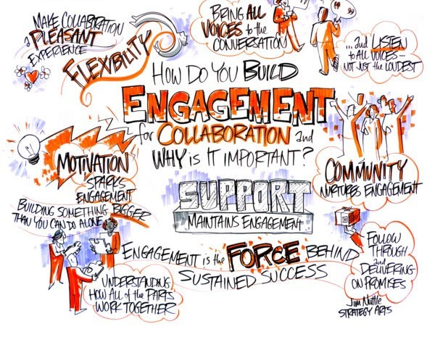
Image by Jim Nuttle, from: https://www.performax360.com/360-stakeholder-engagement-and-collaboration-the-key-to-effective-strategy-management/

What is stakeholder theory?
Stakeholder theory emerged in the business management domain to push back on the narrow and skewed scope of shareholder theory.² Although several variants exist, the unifying idea of all types of stakeholder theory is that the interests of an organization’s stakeholders—“the individuals and groups who are depending on the firm in order to achieve their personal goals and on whom the firm is depending for its existence”³—are just as important as those of the shareholders. Application of stakeholder theory is focused around the relationships between an organization and its stakeholders by identifying mutual interests, maximizing stakeholder wellbeing and enhancing value for all stakeholders.³

How can stakeholder theory improve risk communication?
Below, I highlight two benefits of applying stakeholder theory in risk communication planning:
- By framing a project as creating value for all stakeholders, communication products will be designed with more equity in mind.
A fundamental idea in stakeholder theory is that the interests of all stakeholders are interconnected such that the mission of a manager should generate value for all stakeholders rather than making trade-offs.² While it may seem unrealistic to satisfy everyone’s needs without any trade-offs, stakeholder theory posits using a value creation mindset to reframe situations so that everyone can achieve the best possible outcome.
In risk communication planning, communicators should ensure that their products reflect the best interests of all their stakeholders. The key here is equity – all groups should be seen as equally important because their interests are intertwined with each other’s and with those of the communicator.
- By recognizing the individuality of stakeholders, we reduce likelihood of tokenism from engagements.
A major critique of many stakeholder engagement efforts is how tokenistic they can be, such that stakeholders are only invited to give a project the appearance of inclusiveness while their feedback is disregarded in the actual decision-making process. However, a stakeholder-centric approach necessitates understanding the values, preferences and interests of each stakeholder and how those can be prioritized to improve stakeholder wellbeing.
When running a stakeholder engagement session for a communication program, it will be similarly important to acknowledge the complex social position of each participant and how those can impact their response to risk messaging.
In summary, when we create space for public participation in developing a risk communication program via stakeholder engagement activities, the resulting messaging will naturally be more relevant, credible and effective. One way to successfully engage with stakeholders is to apply concepts of mutual value creation and stakeholder wellbeing from stakeholder theory.

References
- Chelsea Himsworth, Kaylee Byers & Jennifer Gardy. The Mission, the Message, and the Medium: Science and Risk Communication in a Complex World. (Pressbooks).
- Freeman, R. E. Managing for Stakeholders: Trade-offs or Value Creation. J. Bus. Ethics 96, 7–9 (2010).
- Hörisch, J., Freeman, R. E. & Schaltegger, S. Applying Stakeholder Theory in Sustainability Management. Organ. Environ. 27, 328–346 (2014

