Poster: How can we improve academic posters?
Sean Sinden
I decided to write my blog post about some recent attempts to improve the way academic posters are designed and implemented.
As noted in the text, posters are designed to draw in an audience’s attention and highlight a few key messages. However, traditional posters are often packed with too much information, complexity, and jargon to make it a useful medium for communicating the core ideas of the research project.
A traditional poster format
Despite the obvious love and attention to detail that went in to constructing this poster, from the Society for Conservation Biology, you’re not going to get much information from it unless you have 10 minutes to read through the plethora of details. Unfortunately, this is the format that the vast majority of posters at academic conferences follow: introduction, methods, discussion, conclusion. Given how many great research projects are accepted for the poster sessions, this is a wasted opportunity to get across some strong, actionable, and interesting content.
A better way to poster?
A few years ago, Mike Morrison, a PhD student in industrial and organizational psychology, introduced what he called the Better Scientific Poster. In his view, an academic poster should do three things: 1) maximize insight, 2) keep the good stuff (leave time for conversation), and 3) be easy to make. His design is based off of starting with a minimalist design, and adding only the things that are necessary for the poster to be effective; focus on what people need to know and only include what is nice to know if it makes sense to include. So, include the main takeaway in plain language in the centre. He also suggests that we use colour, which could be part of a brand or used to denote what kind of study you are displaying. On one side of the poster, he includes an “ammo bar” which contains the figures, tables, and methods the presenter may need. On the other side, you include a short-form overview of the study, including intro, methods, results, and discussion that can be read in 1-4 minutes. Finally, he adds a QR code that will link to a copy of the poster and the academic poster on which it is based. So, session attendees get to choose how much information they want to take away. They can read the takeaway on move on, they can browse the study overview, interact with the presenter with the help of the ammo bar, or pull out their phone to save the full article for later. This YouTube video is a greater overview of how and why he proposes we should design poster.
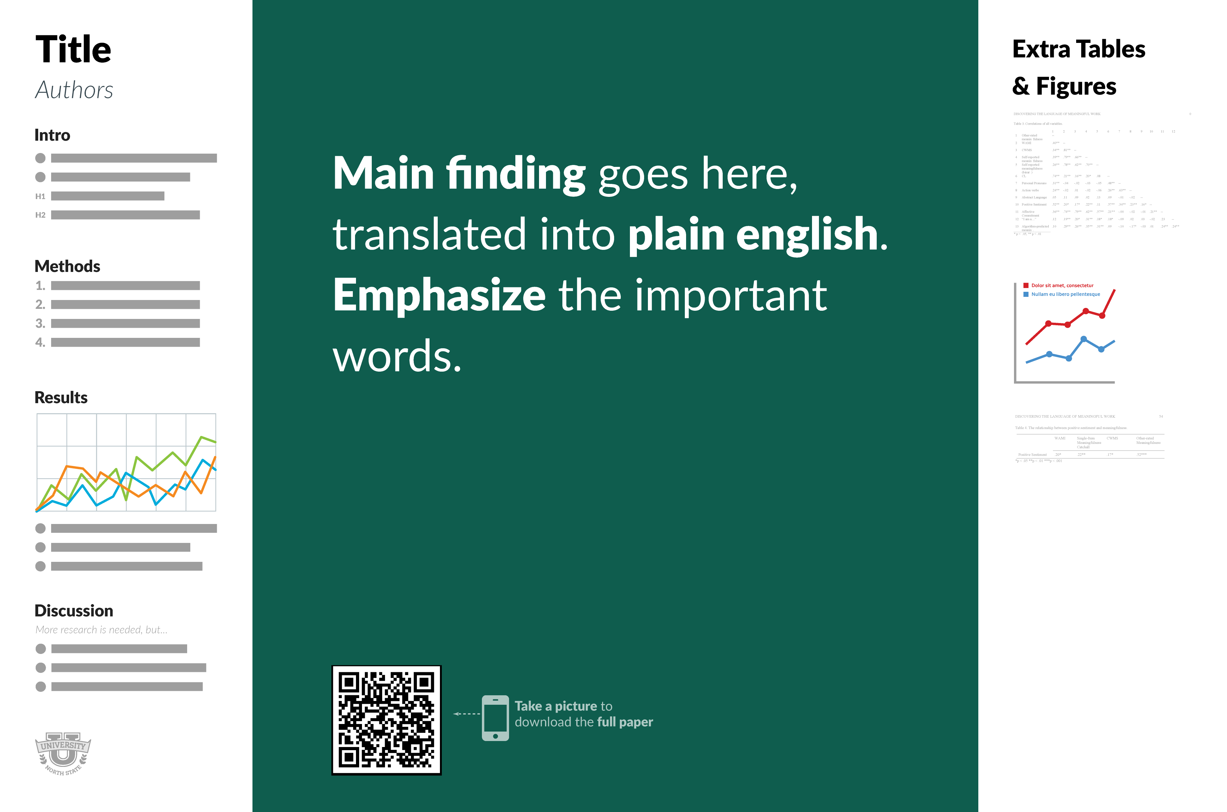
The Better Scientific Poster

Is this our best option?
Morrison’s design is just one approach to making a better poster and other design specialists have criticized his design choices. But the point is that we shouldn’t just repeat the same stodgy poster style used for the last century because that’s what academics have always done. We should strive to look for new ways, inspirations, and schools of thought to inform visual aids for effective research communication.

